
ESLSCA Business School Paris
MSc Project Management
Academic Year November 2024 – May 2026
ENHANCING RISK MANAGEMENT EFFECTIVENESS
IN HYBRID PROJECTS
THROUGH AI-DRIVEN STRATEGIC GOVERNANCE:
A STRUCTURAL EQUATION MODELLING STUDY
Macharla Shivakumar
Supervisor: Olivier Guerinaul

Table of Contents

1 Table of Contents 2
2 List of Figures 4
3 List of Tables 4
4 OBJECTIVES OF THE THESIS 5
5 THE STRUCTURE OF THE THESIS 6
6 AUTHOR’S PRESENTATION 6
7 APPENDICES 7
8 THE FIVE KEY STEPS OF THE THESIS 7
9 CHAPTER-1 10
10 Introduction 10
10.1 Background and Significance of Artificial Intelligence in IT Project Management 12
10.2 Theoretical Background 13
10.2.1 Definition of Project Risk Management 13
10.2.2 AI technologies Applicable to Risk Management 13
10.3 Problem Statement 15
10.4 Research Objectives 17
10.5 Research Questions 18
10.6 Significance of the Study 19
10.6.1 Academic Significance 19
10.6.2 Practical Significance 19
10.6.3 Policy Relevance 20
10.6.4 AI Governance Implications 20
10.7 Structure of the Thesis 21
11 CHAPTER-2 22
12 2. Literature Review 22
12.1 Overview of Risk Management in Project Management 22
12.2 Strategic Risk Management: Theoretical Foundations 23
12.2.1 Hybrid Project Management in Infrastructure Projects 24
12.3 Traditional vs. AI-Driven Risk Management 25
12.4 AI Techniques for Risk Management Practices 25
12.4.1 Cost Modelling Methods 25
12.4.2 Time Modelling Methods 26
12.4.3 Risk Modelling methods 26
12.5 AI-Driven Risk Management for Sustainable Decision-Making 27
12.6 Hypothesis Development 28
12.6.1 Impact of Risk Process Alignment on Risk Management Effectiveness in Hybrid Project Environments 28
12.6.2 Influence of Risk Visibility Integration on Risk Management Effectiveness 29
12.6.3 Effect of Timely Risk Escalation on Risk Management Effectiveness 30
12.6.4 Role of Governance Consistency in Enhancing Risk Management Effectiveness 30
12.6.5 Impact of AI-Driven Risk Analytics Capability on Risk Management Effectiveness 31
12.7 Research Gap 32
13 CHAPTER-3 32
14 Methodology 32
14.1 Introduction 32
14.2 Research design 33
14.3 Ethical Considerations 33
14.3.1 Informed Consent 33
14.3.2 Voluntary Participation 34
14.3.3 Anonymity 34
14.3.4 Data Confidentiality 34
14.4 Objectives 34
14.5 Hypothesis 35
14.6 Conceptual framework 36
14.7 Sample Design 36
14.8 Data collection 37
14.9 Source of data 37
14.9.1 Primary source: 38
14.9.2 Secondary Data 39
14.10 Sampling Technique 39
14.11 Inclusion and exclusion Criteria 39
14.12 Measures 40
14.13 Tools and techniques 41
14.14 Summary 47
15 CHAPTER-4 47
16 Results 47
16.1 Demographics 47
16.2 Discriminant Validity 59
16.3 SEM (Structural Equational Modelling) 61
16.4 Proposed Hypothesis 61
Hypothesis 1 61
Hypothesis 2 64
Hypothesis 3 67
Hypothesis 4 70
Hypothesis 5 73
17 CHAPTER 5 78
18 DISCUSSION 78
19 CHAPTER 6 81
20 CONCLUSION 81
21 References 85

List of Figures

Figure 1 Conceptual Framework of AI-Driven Strategic Risk Management in Hybrid Project Environments 36
Figure 2 Descriptive Statistics of Study Variables 54

List of Tables
Table 1 Comparative analysis—Traditional vs. AI-driven risk management 27
Table 2 Demographic Variables 47
Table 3 Descriptive Statistics of Study Variables 52
Table 4 Factor Loadings from Confirmatory Factor Analysis (CFA) 55
Table 5 KMO and Bartlett's Test 58
Table 6 Convergent Validity Assessment (AVE and Composite Reliability) 58
Table 7 Discriminant Validity Matrix (Fornell-Larcker Criterion) 59
Table 8 Overall Model Fit Indices for Measurement Model 60
Table 10 Regression Weights: (Group number 1 - Default model) 62
Table 11 Model Fit Summary 63
Table 11 Regression Weights: (Group number 1 - Default model) 64
Table 12 Model Fit Summary 66
Table 13 Regression Weights: (Group number 1 - Default model) 67
Table 14 Model Fit Summary 69
Table 16 Regression Weights: (Group number 1 - Default model) 71
Table 17 Model Fit Summary 72
Table 18 SEM Results for H5: AI-Driven Risk Analytics Capability → Risk Management Effectiveness 74
Table 19 Model Fit Indices for H5 Structural Model 75

OBJECTIVES OF THE THESIS
The primary objective of this thesis is to examine the structural determinants of Risk Management Effectiveness in Hybrid Project Environments, with particular emphasis on the role of AI-Driven Strategic Risk Management. Hybrid project environments, characterized by the coexistence of Agile and Waterfall methodologies, introduce structural complexity, governance fragmentation, and dynamic risk interactions that challenge traditional risk management approaches. This research seeks to empirically investigate how strategic governance mechanisms and AI-driven analytical capabilities jointly influence effective risk outcomes.
The specific objectives of the thesis are as follows:
- To examine the impact of Risk Process Alignment between Agile and Waterfall methodologies on Risk Management Effectiveness in hybrid project environments.
- To analyse the influence of Risk Visibility Integration on Risk Management Effectiveness in hybrid projects.
- To assess the effect of Timely Risk Escalation on Risk Management Effectiveness in hybrid project environments.
- To evaluate the role of Governance Consistency in enhancing Risk Management Effectiveness in hybrid projects.
- To examine the impact of AI-Driven Risk Analytics Capability on overall Risk Management Effectiveness in hybrid project environments using Structural Equation Modelling (SEM).

THE STRUCTURE OF THE THESIS
This thesis is structured into six interrelated chapters, each contributing systematically to the development, validation, and interpretation of the research model.
Chapter 1: Introduction
Presents the background of the study, problem statement, research gap, objectives, research questions, significance of the study, and the overall structure of the thesis.
Chapter 2: Literature Review
Reviews existing literature on project risk management, hybrid project methodologies, strategic risk governance, and AI-driven risk analytics. The chapter establishes the theoretical foundation and develops the hypotheses for empirical testing.
Chapter 3: Methodology
Describes the research design, sampling strategy, data collection methods, measurement instruments, ethical considerations, and statistical techniques employed, including Confirmatory Factor Analysis (CFA) and Structural Equation Modelling (SEM).
Chapter 4: Results
Presents the empirical findings of the study, including descriptive statistics, measurement model validation, model fit indices, and hypothesis testing results derived from SEM analysis.
Chapter 5: Discussion
Interprets the findings in relation to existing theories and prior research, highlighting theoretical contributions, managerial implications, and AI governance insights.
Chapter 6: Conclusion
Summarizes the key findings, outlines the contributions of the study, discusses limitations, and provides recommendations for future research.

AUTHOR’S PRESENTATION
The author undertook this research with the objective of contributing to the evolving body of knowledge on AI-driven strategic risk management in hybrid project environments. Recognizing the increasing complexity of contemporary projects and the limitations of traditional risk management approaches, the study adopts a rigorous quantitative methodology to empirically validate an integrated governance and AI capability framework.
The research emphasizes the role of structural alignment, governance consistency, and analytical intelligence as critical enablers of effective risk management. By applying Structural Equation Modelling (SEM) on data collected from professionals across diverse industries, the author ensures methodological robustness and empirical credibility. The findings are intended to support both academic advancement and practical decision-making in complex project ecosystems.

APPENDICES
The appendices provide supplementary material that supports the main body of the thesis and enhances transparency and replicability of the research. These materials are referenced where appropriate within the chapters.
- Appendix A: Research Questionnaire
- Appendix B: Informed Consent Form
- Appendix C: Measurement Scale Items and Sources
- Appendix D: Reliability and Validity Statistics
- Appendix E: CFA and SEM Output Tables
- Appendix F: Ethical Approval and Declarations

THE FIVE KEY STEPS OF THE THESIS
The research process followed five systematic and sequential steps to ensure rigor and coherence:
- Problem Identification and Theoretical Framing
Identification of research gaps in hybrid project risk management and AI governance, followed by development of a theoretically grounded conceptual framework.
- Model Development and Hypothesis Formulation
Construction of an integrated structural model incorporating governance mechanisms and AI-driven risk analytics capability, leading to formulation of testable hypotheses.
- Research Design and Data Collection
Adoption of a quantitative research design, development of validated measurement instruments, and collection of primary data from professionals involved in hybrid project environments.
- Data Analysis and Model Validation
Application of statistical techniques including reliability analysis, Confirmatory Factor Analysis (CFA), and Structural Equation Modelling (SEM) to test relationships and validate the model.
- Interpretation, Contribution, and Conclusion
Interpretation of empirical findings, articulation of theoretical and practical contributions, discussion of limitations, and formulation of recommendations for future research
Abstract
The increasing adoption of hybrid project methodologies integrating Agile adaptability with Waterfall structure has introduced significant complexity into organizational risk governance. Traditional risk management approaches, primarily reliant on manual assessment and static control frameworks, often struggle to address the dynamic and fragmented nature of hybrid environments. Concurrently, Artificial Intelligence (AI) has emerged as a strategic enabler of predictive analytics, real-time monitoring, and data-driven decision support. However, limited empirical research has examined how AI capability interacts with structural governance mechanisms to influence overall risk management effectiveness in hybrid project settings. This study investigates the structural determinants of Risk Management Effectiveness in Hybrid Project Environments, with particular emphasis on AI-Driven Risk Analytics Capability. A quantitative research design was employed using primary data collected from 384 project professionals across diverse industries. Structural Equation Modelling (SEM) was utilized to examine the direct effects of five key dimensions: Risk Process Alignment, Risk Visibility Integration, Timely Risk Escalation, Governance Consistency, and AI-Driven Risk Analytics Capability. The findings reveal that Risk Process Alignment, Governance Consistency, and AI-Driven Risk Analytics Capability have statistically significant and positive effects on Risk Management Effectiveness. Among these, AI-Driven Risk Analytics Capability emerged as one of the strongest predictors, indicating that advanced analytical intelligence substantially enhances predictive foresight and decision quality in hybrid settings. In contrast, Risk Visibility Integration demonstrated only a marginal direct effect, while Timely Risk Escalation did not exhibit a statistically significant influence. These results suggest that structural coherence and technological capability exert greater impact on risk outcomes than operational transparency or escalation responsiveness alone. The study contributes to project management and risk governance literature by positioning AI capability as a strategic structural determinant rather than a peripheral technological tool. It advances hybrid project theory by demonstrating that effectiveness depends on deliberate integration of governance consistency and process alignment. Practically, the findings provide evidence-based guidance for managers seeking to strengthen risk governance in complex project ecosystems. The research concludes that sustainable risk performance in hybrid environments requires integrated structural alignment, governance stability, and AI-driven analytical intelligence.
Keywords: AI-Driven Risk Management, Hybrid Project Environments, Structural Equation Modelling (SEM), Governance Consistency, Risk Process Alignment, Risk Visibility Integration, Timely Risk Escalation, Risk Analytics Capability, Project Risk Governance, Risk Management Effectiveness

CHAPTER-1

Introduction
The contemporary project landscape is undergoing a profound transformation driven by technological advancement, organizational globalization, and increasing environmental volatility. Projects today are no longer isolated, linear undertakings; instead, they are complex socio-technical systems embedded within dynamic organizational and external environments. This complexity has significantly increased project exposure to uncertainty, making risk an inherent and continuous feature across the project lifecycle rather than a discrete event addressed at predefined stages (Flyvbjerg, 2017; Williams et al., 2010).
Despite the centrality of risk in modern projects, traditional project risk management practices remain largely rooted in deterministic planning paradigms. These practices typically rely on static risk registers, periodic assessments, and subjective expert judgment, which often fail to capture evolving risk interactions, emergent threats, and non-linear causal relationships (Ward & Chapman, 2003; Aven, 2016). As project environments become more data-intensive and time-sensitive, such approaches increasingly struggle to provide timely, accurate, and actionable insights for decision-makers.
Artificial Intelligence (AI) has emerged as a critical enabler capable of addressing these limitations by fundamentally redefining how project risks are identified, assessed, and managed. Rather than serving as a standalone automation tool, AI represents a paradigm shift toward adaptive, learning-based, and evidence-driven risk governance. By leveraging machine learning, predictive analytics, and intelligent monitoring systems, AI enables continuous sensing of project conditions, early detection of weak risk signals, and dynamic updating of risk profiles in real time (Jordan & Mitchell, 2015; Raisch & Krakowski, 2021).
AI-driven analytical models are particularly effective in environments characterized by large volumes of heterogeneous data. Project data—ranging from schedules, budgets, and performance metrics to communication logs and stakeholder feedback—can be integrated and analyzed to uncover latent patterns and interdependencies that are beyond human cognitive capacity (Provost & Fawcett, 2013; Biesenthal et al., 2022). Predictive models built on such data can forecast schedule slippages, cost escalations, and performance degradation with greater accuracy than traditional rule-based methods, enabling earlier and more targeted risk mitigation interventions (Zhang et al., 2021; Shao et al., 2025).
From a decision-theoretic perspective, AI-based risk management systems address inherent limitations of human judgment, including bounded rationality, cognitive bias, and information overload (Simon, 1997; Kahneman, 2011). While human expertise remains essential for contextual interpretation and ethical judgment, AI enhances decision quality by providing consistent, scalable, and data-driven insights. This synergy between human and artificial intelligence has given rise to hybrid decision-making models that improve both the speed and robustness of risk-related decisions in complex projects (Raisch & Krakowski, 2021; Hanaysha et al., 2021).
The growing maturity of AI technologies has accelerated their adoption in large-scale and mission-critical projects. Organizations operating in sectors such as manufacturing, finance, aerospace, and public infrastructure increasingly embed AI-based systems within their project governance frameworks to enhance visibility, automate risk monitoring, and optimize response strategies (Bughin et al., 2018; Treacy et al., 2025). These developments indicate a shift from experimental adoption toward institutionalized use of AI in project risk management, signaling its strategic importance for organizational resilience and competitiveness.
At the same time, the integration of AI into project management raises important questions regarding governance, transparency, and managerial control. Effective use of AI requires alignment between technological capabilities, organizational processes, and decision authority structures. Without such alignment, AI systems risk becoming opaque tools that generate outputs without meaningful integration into managerial workflows (Marnewick et al., 2020; Dwivedi et al., 2023). Consequently, understanding how AI-enabled risk management operates within real project contexts has become a critical area of scholarly inquiry.

Background and Significance of Artificial Intelligence in IT Project Management
The relevance of AI is particularly pronounced in the context of IT project management, where uncertainty, complexity, and rapid change are defining characteristics. IT projects often involve evolving requirements, fast-paced technological innovation, and interdependent system architectures, making them highly susceptible to risks related to scope creep, integration failure, and resource misalignment (Sauer et al., 2007; Standish Group, 2020). Historical evidence consistently shows that a significant proportion of IT projects fail to meet their original objectives, underscoring the need for more advanced and adaptive risk management approaches.
Traditional IT project management frameworks emphasize upfront planning and periodic control mechanisms, which may be insufficient in environments where requirements and technologies evolve continuously. Artificial Intelligence introduces a fundamentally different approach by enabling continuous, real-time decision support across the entire project lifecycle. Through the application of machine learning, natural language processing (NLP), and advanced analytics, AI systems assist project managers in interpreting complex information streams and anticipating future project states with greater accuracy (Wamba et al., 2021; Siau & Wang, 2018).
One of the most significant contributions of AI to IT project management lies in its ability to integrate structured and unstructured data sources. Structured data, such as schedules, budgets, and defect metrics, can be combined with unstructured data, including emails, meeting transcripts, and issue reports, to generate a more comprehensive and nuanced understanding of project risk exposure (Provost & Fawcett, 2013; Biesenthal et al., 2022). This holistic data integration enables earlier detection of emerging risks and supports proactive rather than reactive management strategies.
AI systems further enhance IT project risk management through adaptive learning capabilities. As projects progress and new data become available, AI models can update their predictions and recommendations, maintaining relevance in dynamic environments. This continuous learning feature is particularly valuable in IT projects, where changing stakeholder expectations and technological dependencies can rapidly alter risk profiles (March, 1991; Zhang et al., 2021).
In addition to analytical improvements, AI has reshaped coordination and communication mechanisms within IT project teams. AI-enabled dashboards, intelligent assistants, and automated reporting tools facilitate real-time information sharing and improve transparency across geographically distributed teams (Fountaine et al., 2019). Enhanced visibility and communication are critical for managing interdependencies and ensuring timely escalation of risks in complex IT projects.
From a strategic and sustainability perspective, AI-enabled risk management contributes to long-term organizational resilience. Sustainable project outcomes depend not only on meeting immediate performance targets but also on managing risks that threaten long-term value creation, social responsibility, and resource efficiency (Elkington, 1997; United Nations, 2015). By improving risk anticipation, decision quality, and adaptive capacity, AI strengthens organizational ability to navigate uncertainty and supports more sustainable and responsible IT project execution (Aven & Renn, 2010)

Theoretical Background

Definition of Project Risk Management
Project risk management is a systematic and structured process that aims to identify, assess, and manage risks that may affect project results. It is a process that enables the measurement of risks and the development of strategies to mitigate risks and avoid undesirable outcomes (Faruk, 2025). (Kaplan & Garrick, 1981) describe risk as a product of the probability of occurrence of an event and its potential consequences. This is a quantitative method that enables organizations to manage risks and develop strategies to avoid disruptions.
An effective risk management process includes a number of key elements, such as risk identification, risk analysis, risk response planning, and risk monitoring. Risk identification is the process of identifying potential risks that may impede the success of a project, while risk analysis is the process of determining the risk potential of each risk situation. After the risks have been analysed, risk response plans can be developed, which may include risk avoidance, risk reduction, risk transfer, or risk acceptance.

AI technologies Applicable to Risk Management
The incorporation of artificial intelligence (AI) in risk management has revolutionized the way risks are identified, analysed and mitigated. AI-based risk management tools are more efficient, accurate, and scalable than their conventional counterparts, allowing organizations to effectively mitigate risks in real-time. AI-based risk assessment employs a range of advanced technologies to enhance predictive accuracy and automate risk mitigation plans (Dutta, D., & Bose, 2015). The primary AI technologies that can be leveraged for risk management are:
Machine Learning (ML) – Machine learning algorithms are used to analyse large datasets to detect patterns and predict risks, and then suggest ways to mitigate them. Machine learning models improve their accuracy levels by learning from new data, making them very effective in detecting anomalies, predicting system failures, and identifying vulnerabilities in critical infrastructure systems.
Natural Language Processing (NLP) – NLP technologies help AI systems to derive meaningful insights from unstructured text sources like security updates, intelligence meetings, social media updates, and live communications. By analysing language patterns, NLP-based AI solutions can detect potential threats, point out misinformation campaigns, and offer warning signs for potential risks.
Deep Learning (DL) – Deep learning algorithms, especially neural networks, improve risk detection abilities by processing unstructured data, like images, videos, and sensor inputs. Deep learning models are commonly employed in domains such as biometric security, surveillance analytics, and automated anomaly detection in cybersecurity solutions (Wenzel, M., Krause, B., & Wagner, 2022).
Through the integration of these AI technologies, risk management frameworks can be made more adaptable, precise, and responsive. AI-based risk assessment tools are capable of handling large amounts of diverse data, thus minimizing the possibility of human error and allowing organizations to shift from a reactive to a proactive risk management strategy. The ability of AI to quickly analyse risk scenarios, simulate risks, and provide recommendations on the best risk mitigation strategies makes it a crucial component of risk governance frameworks.
Theoretical background of risk management offers the required context to appreciate the role of AI in improving risk identification, mitigation, and response strategies. Conventional risk management strategies, although helpful, have become less effective in dealing with the dynamic risks that critical infrastructure and national security projects are exposed to. The adoption of AI technologies such as ML, NLP, and DL has brought about a paradigm shift in risk management strategies, enabling real-time analysis of threats and automated decision support. As AI technology evolves, its application in risk management will become more prominent, leading to improvements in resilience, efficiency, and overall security in high-risk sectors.

Problem Statement
The rapid evolution of project environments particularly the rise of hybrid methodologies combining Agile flexibility with Waterfall structure has significantly altered the nature of risk management. While traditional project risk management literature has extensively examined structured risk identification, qualitative and quantitative assessment methods, and governance frameworks, most studies are grounded in conventional predictive environments. These studies emphasize documentation, control mechanisms, and hierarchical escalation structures but do not adequately address the procedural complexity introduced when adaptive and predictive methodologies coexist within the same project ecosystem.
In parallel, a growing body of research has explored the application of Artificial Intelligence (AI) in project management and risk governance. These studies primarily focus on machine learning for cost prediction, predictive analytics for schedule overruns, anomaly detection in IT systems, and automation of risk monitoring dashboards. Although this body of literature demonstrates the technological potential of AI in improving forecasting accuracy and operational efficiency, it largely treats AI as a standalone technological enhancement rather than as an integrated strategic capability embedded within broader governance and procedural systems.
A critical limitation in existing scholarship is the lack of empirical integration between structural governance mechanisms and AI-driven analytical capabilities within hybrid project contexts. Most prior studies examine either (1) traditional risk management practices without AI integration, or (2) AI-based analytics without embedding them within formal governance structures and aligned risk processes. There remains a significant absence of comprehensive structural models that simultaneously test how procedural alignment, governance consistency, operational visibility, escalation mechanisms, and AI-driven analytics interact to influence overall risk management effectiveness.
Moreover, the majority of empirical investigations into AI-enabled risk management rely on descriptive case studies, conceptual frameworks, or technology adoption surveys. Very few studies employ rigorous multivariate statistical approaches particularly Structural Equation Modelling (SEM) to examine causal relationships among governance structures, process alignment, AI capability, and performance outcomes. The absence of SEM-based validation limits the ability to understand not merely whether AI contributes to risk management, but how it structurally interacts with governance and process mechanisms to produce measurable effectiveness.
Hybrid project environments further intensify this gap. By design, hybrid methodologies integrate Agile adaptability with Waterfall predictability. While this integration offers flexibility and control, it also introduces structural fragmentation. Agile teams often operate with decentralized decision-making, iterative planning cycles, and lightweight documentation, whereas Waterfall components rely on formal stage-gates, structured risk registers, and hierarchical reporting channels. This methodological duality can create inconsistencies in risk documentation, ambiguity in escalation authority, duplication of monitoring mechanisms, and misalignment in governance oversight. Without deliberate structural harmonization, risk management processes may operate in parallel silos rather than as a coherent system.
Existing research has not sufficiently examined how AI capability functions within such fragmented environments. It remains unclear whether AI-driven analytics independently improves risk outcomes, or whether its effectiveness depends on aligned processes and consistent governance frameworks. Similarly, the relative contribution of structural factors (such as governance consistency and process alignment) versus operational mechanisms (such as visibility and escalation) has not been empirically disentangled in hybrid contexts.
Therefore, a significant research gap exists at the intersection of AI capability, strategic risk governance, and hybrid project environments. There is a need for an integrated empirical model that simultaneously examines multiple structural dimensions of risk governance and evaluates their direct influence on risk management effectiveness using robust statistical techniques. Specifically, the literature lacks:
- Empirical SEM-based validation of AI-driven strategic risk management models in hybrid project settings.
- Integrated structural testing of AI capability alongside governance consistency and risk process alignment.
- Comparative assessment of structural versus operational risk mechanisms within hybrid environments.
- Evidence clarifying how fragmentation inherent in hybrid methodologies influences risk governance effectiveness.
This study addresses these gaps by developing and empirically testing a comprehensive structural model of AI-driven strategic risk management within hybrid project environments. Using data collected from 384 professionals and analysed through Structural Equation Modelling (SEM), the study examines the direct influence of Risk Process Alignment, Risk Visibility Integration, Timely Risk Escalation, Governance Consistency, and AI-Driven Risk Analytics Capability on Risk Management Effectiveness. By integrating technological capability with structural governance dimensions, the research moves beyond isolated examinations of AI tools or traditional risk processes and provides a unified framework for understanding how hybrid risk governance systems can be optimized.
In doing so, the study contributes to advancing project risk management theory by positioning AI capability not as an auxiliary tool, but as a strategic enabler embedded within aligned procedural and governance architectures. It also responds to the increasing practical need for evidence-based guidance on managing risk in complex hybrid environments where methodological fragmentation and digital transformation converge.

Research Objectives
The primary objective of this study is to examine the structural determinants of Risk Management Effectiveness in Hybrid Project Environments, with particular emphasis on the role of AI-driven strategic risk management capabilities. In hybrid contexts where Agile and Waterfall methodologies coexist, risk governance mechanisms must operate cohesively despite procedural and structural differences. This study therefore seeks to empirically investigate how both structural and technological dimensions influence overall risk performance outcomes.
Specifically, the study aims to achieve the following objectives:
- To examine the impact of Risk Process Alignment between Agile and Waterfall methodologies on Risk Management Effectiveness in hybrid project environments.
- To analyse the influence of Risk Visibility Integration on Risk Management Effectiveness in hybrid projects.
- To assess the effect of Timely Risk Escalation on Risk Management Effectiveness in hybrid project environments.
- To evaluate the role of Governance Consistency in enhancing Risk Management Effectiveness in hybrid projects.
- To examine the impact of AI-Driven Risk Analytics Capability on overall Risk Management Effectiveness in hybrid project environments.
Through these objectives, the study seeks to develop and empirically validate an integrated structural model that explains how procedural alignment, governance stability, operational mechanisms, and advanced analytical capability collectively shape risk governance outcomes in complex hybrid project settings.

Research Questions
In order to address the identified research gap and achieve the stated objectives, this study formulates the following research questions. These questions are designed to empirically examine the structural relationships between key dimensions of AI-driven strategic risk management and Risk Management Effectiveness in Hybrid Project Environments:
RQ1: Does Risk Process Alignment between Agile and Waterfall methodologies significantly influence Risk Management Effectiveness in hybrid project environments?
RQ2: Does Risk Visibility Integration significantly influence Risk Management Effectiveness in hybrid project environments?
RQ3: Does Timely Risk Escalation significantly influence Risk Management Effectiveness in hybrid project environments?
RQ4: Does Governance Consistency significantly influence Risk Management Effectiveness in hybrid project environments?
RQ5: Does AI-Driven Risk Analytics Capability significantly influence Risk Management Effectiveness in hybrid project environments?
Collectively, these research questions seek to determine which structural and technological dimensions serve as primary drivers of effective risk governance in hybrid projects. By examining these relationships simultaneously through Structural Equation Modelling (SEM), the study aims to provide empirical clarity on the relative contribution of procedural alignment, governance stability, operational mechanisms, and AI-enabled analytics to overall risk management performance.

Significance of the Study
The significance of this study lies in its contribution to advancing theoretical understanding, improving managerial practice, informing policy considerations, and clarifying the governance implications of Artificial Intelligence (AI) in hybrid project environments. As organizations increasingly adopt hybrid methodologies and integrate AI-driven tools into risk governance systems, there is a growing need for empirically grounded insights into how structural and technological dimensions collectively influence risk management effectiveness.

Academic Significance
From an academic perspective, this study contributes to the project management and risk governance literature in several important ways. First, it extends traditional project risk management theory by integrating AI-Driven Risk Analytics Capability as a structural determinant of risk management effectiveness rather than treating AI as merely a technological tool. Second, it advances hybrid project management research by empirically examining how procedural alignment and governance consistency operate within environments that combine Agile adaptability and Waterfall structure.
Furthermore, the study addresses a methodological gap by employing Structural Equation Modelling (SEM) to test an integrated framework that simultaneously evaluates multiple dimensions of strategic risk management. Previous research has largely examined these factors in isolation or through descriptive approaches. By validating a comprehensive structural model, the study strengthens theoretical clarity regarding the relative influence of process alignment, governance mechanisms, visibility integration, escalation responsiveness, and AI capability on risk performance outcomes.

Practical Significance
Practically, the findings provide evidence-based guidance for project managers, PMO leaders, risk officers, and organizational executives operating in hybrid project environments. The study identifies which structural dimensions most strongly influence risk management effectiveness, enabling decision-makers to prioritize investments and interventions accordingly.
For instance, organizations can focus on harmonizing risk processes across Agile and Waterfall components, strengthening governance consistency, and strategically developing AI-driven analytics capability rather than relying solely on operational transparency mechanisms. The results help managers understand that risk visibility and escalation mechanisms are supportive but insufficient without structural integration and analytical maturity. This insight assists organizations in allocating resources more effectively to enhance project resilience and performance.

Policy Relevance
At a broader organizational and institutional level, the study has policy relevance for corporate governance frameworks and digital transformation strategies. As enterprises formalize hybrid methodologies and adopt AI-based systems for monitoring and decision support, internal risk governance policies must evolve to accommodate both procedural complexity and technological integration.
The research highlights the need for structured governance standards that ensure accountability, alignment of risk processes, and responsible deployment of AI tools. Policymakers within organizations such as boards, executive committees, and enterprise risk management units can use the findings to develop policies that integrate AI capability into formal risk governance architectures rather than allowing technological tools to operate in isolation from established oversight mechanisms.

AI Governance Implications
The study also contributes to the emerging discourse on AI governance in organizational contexts. As AI systems increasingly influence risk identification, prioritization, and decision-making processes, questions of accountability, transparency, and control become critical. The findings demonstrate that AI capability yields stronger impact when embedded within consistent governance frameworks and aligned risk processes. This suggests that effective AI governance requires structural integration rather than standalone technological deployment.
By empirically showing the interaction between AI-driven analytics capability and governance consistency, the study reinforces the importance of establishing oversight structures, clearly defined decision rights, and standardized reporting mechanisms when implementing AI in project risk management. This has implications for responsible AI adoption, ethical oversight, and sustainable digital transformation in complex project ecosystems.
Overall, the study provides a comprehensive contribution by bridging technological innovation, governance architecture, and procedural alignment within hybrid project environments. It offers a structured pathway for strengthening AI-driven strategic risk management while maintaining accountability, coherence, and performance effectiveness in increasingly complex project settings.

Structure of the Thesis
This thesis is organized into six chapters to provide a systematic and coherent presentation of the research process and findings.
Chapter 1: Introduction presents the background of the study, research gap, objectives, research questions, significance of the study, and overall structure of the thesis.
Chapter 2: Literature Review examines existing research on project risk management, hybrid project environments, strategic risk governance, and AI-driven analytics capability. It develops the theoretical framework and formulates the study hypotheses.
Chapter 3: Methodology outlines the research design, sampling strategy, data collection procedures, measurement instruments, and statistical techniques used for analysis, including reliability, validity, and Structural Equation Modelling (SEM).
Chapter 4: Results present the empirical findings, including descriptive statistics, measurement model validation, model fit indices, and hypothesis testing results derived from SEM analysis.
Chapter 5: Discussion interprets the findings in relation to existing literature and theoretical foundations, highlighting theoretical implications, managerial insights, and AI governance considerations.
Chapter 6: Conclusion summarizes the key findings, outlines the contributions of the study, discusses limitations, and provides recommendations for future research.
This structured progression ensures logical development from conceptual foundations to empirical validation and practical implications, providing a comprehensive understanding of AI-driven strategic risk management in hybrid project environments.

CHAPTER-2

2. Literature Review
The effective management of risks is widely recognized as a critical determinant of project success, particularly in complex and dynamic environments where uncertainty, stakeholder demands, and regulatory requirements converge. Traditional project management approaches, such as the Waterfall methodology, emphasize structured planning and linear execution, providing predictability but often lacking flexibility to respond to emergent risks, while agile methodologies offer adaptability and iterative processes yet face limitations in large-scale infrastructure projects. Hybrid project management, which integrates the predictability of traditional approaches with the responsiveness of Agile, has emerged as a practical solution to address these challenges, particularly in infrastructure and large-scale projects. Concurrently, the advent of artificial intelligence (AI) has transformed risk management by enabling predictive analytics, real-time monitoring, and data-driven decision-making, enhancing the accuracy and effectiveness of risk mitigation strategies.
This literature review critically examines the evolution of project risk management, the theoretical foundations of strategic risk governance, and the role of AI-enabled tools and methodologies in enhancing risk management effectiveness within hybrid project environments, highlighting key enablers, gaps, and opportunities for research-driven improvements.

Overview of Risk Management in Project Management
Project risk management (PRM) is essential for project success, focusing on identifying, analyzing, and mitigating risks throughout a project's lifecycle. It employs systematic approaches, integrating risk assessment and mitigation strategies, alongside ongoing monitoring to reduce uncertainties. According to (Okafor, 2021) effective PRM involves core principles, methodologies, and best practices, emphasizing the role of risk management tools, stakeholder engagement, and structured decision-making frameworks. Case studies highlighted in the research demonstrate that proactive risk management prevents cost overruns, schedule delays, and quality issues, stressing the importance of integrating risk management into project planning and execution to enhance resilience and sustainability.
(Adebayo, 2024) analyzed best practices in risk management, including risk identification, assessment techniques, and mitigation strategies. It emphasizes the importance of proactively seeking potential threats and prioritizing risks based on their impact. The article also discussed the evolving nature of project risks, exacerbated by technological advancements and global challenges like cybersecurity threats. A comprehensive table outlines key risk management tools, providing insights into effective applications across various sectors. Strong risk management not only protects project outcomes but also fosters organizational resilience, enabling adaptation to change and enhancing competitive advantage.
(Ebule, 2025) highlighted the increasing need for effective risk management in modern projects due to increasing complexity and uncertainty. It explores best practices in risk management and opportunity exploitation, focusing on risk definition, assessment, and management strategies within the context of project management. Key measures include stakeholder management and both quantitative and qualitative risk assessment methods. The discussion is bolstered by live examples, highlighting the role of effective risk management in facilitating positive change.
(Abazid & Harb, 2018) Conceptualized risk and its consequences in construction and management operations. It discusses utilities and techniques for risk control in the construction industry, alongside the effect of risk on project assessment. The research focused on effective risk management implementation, evaluating various techniques to reduce risk, understanding the utility of risk management implementation, and identifying factors that influence risk management throughout project life cycles. Additionally, it distinguishes risk management practices specific to construction projects in the Arab region.

Strategic Risk Management: Theoretical Foundations
Strategic risk management (SRM) extends conventional risk management by integrating risk considerations into organizational strategy and governance frameworks. SRM emphasizes aligning risk policies with strategic objectives, promoting executive oversight, performance monitoring, and risk-informed decision-making. The theoretical foundations of SRM are derived from Enterprise Risk Management (ERM) theory, governance theory, dynamic capability theory, and the resource-based view (RBV). These frameworks collectively highlight the importance of proactive risk governance in sustaining organizational resilience and competitive advantage.
While SRM frameworks provide robust principles for governance and oversight, the literature suggests that empirical research on AI-enabled strategic governance in hybrid project contexts remains limited. Hybrid projects, which combine traditional planning with agile methodologies, present unique governance challenges that require integrating adaptive decision-making processes with predictive risk analytics.

Hybrid Project Management in Infrastructure Projects
Project management has historically relied on structured, sequential models, particularly the Waterfall approach, to manage large-scale infrastructure developments. These methods emphasize upfront planning, scope definition, detailed scheduling, and linear execution, offering predictability and control (Kerzner, 2023). In infrastructure projects where physical deliverables, fixed budgets, and regulatory scrutiny dominate such predictability is crucial. However, rigid models often fail to accommodate mid-project changes, emerging risks, or stakeholder demands, particularly in volatile economic or environmental conditions (Hosseini et al., 2023).
The limitations of traditional methods in dynamic environments have fueled interest in more adaptive approaches. Agile project management, developed for fast paced software development environments, is characterized by short iteration cycles, frequent customer feedback, minimal upfront planning, and collaborative team structures (Hoda & Murugesan, 2023). Despite these advantages, the direct application of Agile in infrastructure is constrained by dependencies on physical assets, strict compliance requirements, and longer project durations (Khan & Al-Shammari, 2023).
Hybrid project management methodologies emerged as a practical response to the incompatibility of pure Agile in non-software environments. These approaches aim to combine the adaptability of Agile with the structure and control of traditional models (Praveen, 2025). In large-scale infrastructure settings, hybrid methodologies typically apply Agile principles in design, planning, or stakeholder communication phases, while maintaining traditional controls in procurement, construction, and regulatory compliance. Research by (Bjorvatn & Wald, 2023) emphasizes that hybrid approaches are particularly suited for projects operating in turbulent or uncertain conditions, where flexibility is needed but must be balanced with governance. Similarly, (Denicol et al., 2022) assert that the organizational architecture of megaprojects supports hybrid configurations, with core teams functioning iteratively while broader functions follow established protocols.

Traditional vs. AI-Driven Risk Management
Traditional risk management techniques and AI-driven risk management approaches significantly differ in their methods of data handling processes, analysis, and decision-making. In the traditional approach, risk management heavily depends on manual efforts to gather and scrutinize data from records and rely on insights from experts (Lundqvist, 2015). In contrast, AI-driven risk management exploits machine learning and sophisticated algorithm methods to effectively examine and evaluate immense volumes of data (Zigiene et al., 2019). AI systems can decipher complex data patterns, assess correlations, and forecast real-time potential hazards empowering organizations to react promptly and efficiently. Traditional approaches may struggle to scale and adapt to changing risk landscapes (Hopkin, 2018). Whereas AI-driven systems are highly scalable and adaptable. Traditional risk management relies on human judgments and familiarities, low initial investment, adaptability, and subjectivity; however, it may have limitations in scalability, response time, and predictive analysis. On the other hand, AI-driven risk management offers advanced analytics, predictive capabilities, automation, real-time insights, and a reduced potential for bias, but it may require greater technical expertise and raise concerns about data privacy and overreliance on technology (Schuett, 2023). Overall, AI-driven methods prioritize advanced analytics and automation, while traditional approaches are based on human judgment and familiarity. However, each of these approaches offers distinct advantages and complications in managing risks.

AI Techniques for Risk Management Practices
AI technologies have enhanced risk management practices by improving accuracy and efficiency in cost modelling, time forecasting, and risk modelling. These approaches allow organizations to leverage historical and real-time data to inform decisions, optimize resource allocation, and proactively mitigate risks.

Cost Modelling Methods
Cost modelling methods are compassed through a three-stage model comprising input, process, and output with a key aim of encompassing cost data, evaluation data, productivity, and safety data (Datta & Roy, 2010). To mitigate the volatility in project costs, a regularization neural network was formulated particularly for cost estimation purposes. An illustration of this is to forecast the costs associated with a reinforced concrete structural unit that is engineered to offer more stable and accurate cost estimation. Moreover, the utilization of artificial neural networks (ANNs) was carried out to monitor project productivity and safety (Matel et al., 2022). A three-layered network containing a fuzzy output structure appeared to be most effective considering the subjective characteristics of a significant portion of the data. In order to improve the accuracy of scheduling analyses and risk identification, extensive AI databases have been established. These databases enable project managers to input new project tasks and instantaneously acquire feedback regarding predicted actual durations (Pan & Zhang, 2021). The verification process involved contrasting the AI output with real project data, demonstrating its validity, and offering invaluable information about potential project influencers for the intent of risk mitigation strategy. This method brings substantial time efficiency when compared to conventional spreadsheet approaches and advances the managerial ability for sustainable decision-making.

Time Modelling Methods
AI approaches for risk management processes contain a range of time modelling methods that attempt to predict the timing and duration of prospective risks accurately. These techniques deploy AI algorithms to evaluate past data, determine trends, and predict the timing of upcoming occurrences (Salehi & Burgueño, 2018). A time series analysis is a commonly employed methodology that entails the examination of sequential datasets in order to detect patterns, seasonal variations, and anomalies. Time modelling in risk management often involves the utilization of techniques such as autoregressive integrated moving averages (ARIMA) and seasonal decomposition of time series (STL) (He et al., 2022) (Schaffer et al., 2021). Furthermore, machine learning methods, such as recurrent neural networks (RNNs) and long short-term memory (LSTM) networks, possess the capability to effectively capture temporal relationships within datasets, enabling them to generate predictions pertaining to forthcoming time points (Sherstinsky, 2020). Top management can improve their capacities to anticipate and mitigate risks that occur over time by integrating time modelling methodologies into their risk management procedures, resulting in improved strategic planning and decision-making.

Risk Modelling methods
The application of artificial intelligence (AI) technology has had a profound impact on risk management practices, namely in the context of risk modelling procedures. These techniques utilize sophisticated algorithms and machine learning methods to analyse massive amounts of data, identify complex patterns, and forecast possible dangers with unprecedented accuracy in comparison to conventional methods (Belhadi et al., 2022). Prominent risk modelling techniques in the field of artificial intelligence encompass machine learning algorithms such as decision trees and neural networks, natural language processing for the analysis of textual data, and fuzzy logic for managing uncertainty (Bansal, M.; Goyal, A.; Choudhary, 2022). The integration of AI methodologies into risk management practices facilitates enhanced understanding, quantification, and the mitigation of risks in various industries, including finance, insurance, cybersecurity, and project management. In turn, this integration fosters more informed decision-making processes and yields improved outcomes in risk management.

AI-Driven Risk Management for Sustainable Decision-Making
The existing literature on decision-making identified different enablers that are raising organizations’ concerns for sustainable decision-making practices (Isensee et al., 2021) (Yigitcanlar, 2021) (Abid et al., 2021) (Javaid et al., 2022). In the context of AI, as suggested by (Yaseen, 2021), leveraging AI for proactive risk identification, organizations can analyse vast datasets to pinpoint potential risks across various operational facets, including environmental impact, supply chain resilience, and regulatory compliance. Moreover, AI-driven risk assessments offer a comprehensive approach, considering environmental, social, and economic factors, facilitating holistic evaluations and the prioritization of actions to minimize adverse effects on sustainability objectives (Abid et al., 2021) . AI-enabled data driven decision-making assists businesses to act on insights from past data and prediction models, ensuring that actions are in accordance with sustainability objectives and risk-free. In addition to maximizing sustainability impact while minimizing waste and optimizing overall performance, AI improves resource allocation by spotting inefficiencies and redirecting resources accordingly. By keeping checks on data in real-time, organizations are able to adjust to unfamiliar circumstances rapidly, availing full advantage of sustainability potential while mitigating risks (Ahmed et al., 2022). Therefore, risk management enabled by AI not only aids sustainability initiatives but also facilitates organizations’ survival and thriving in a constantly changing world.

Table 1 Comparative analysis—Traditional vs. AI-driven risk management
Aspect | Traditional Risk Management | AI-Driven Risk Management
Familiarity | ✓ | ✗
Human Judgment | ✓ | ✓
Low Initial Investment | ✓ | ✗
Adaptability | ✓ | ✗
Subjectivity | ✓ | ✗
Limited Scalability | ✓ | ✓
Slow Response Time | ✓ | ✗
Difficulty in Predictive Analysis | ✓ | ✗
Advanced Analytics | ✗ | ✓
Predictive Capabilities | ✗ | ✓
Automation | ✗ | ✓
Real-time Insights | ✗ | ✗
Complexity | ✓ | ✗
Data Privacy Concerns | ✓ | ✓
Potential for Bias | ✓ | ✓
Overreliance on Technology | ✗ | ✓
Source: self-constructed from (Baryannis et al., 2019) (Galaz et al., 2021) (Lundqvist, 2015) (Afzal et al., 2021) (Aziz & Dowling, 2019) (de Araújo Lima et al., 2020).

Hypothesis Development

Impact of Risk Process Alignment on Risk Management Effectiveness in Hybrid Project Environments
Risk process alignment refers to the consistent integration and synchronization of risk management activities such as risk identification, analysis, response planning, and monitoring across both Agile and Waterfall methodologies within hybrid project environments. Hybrid methodologies combine the structured planning of Waterfall with the iterative flexibility of Agile to address complex project requirements. Research shows that hybrid risk management enhances resilience and delivers superior project outcomes by blending proactive risk identification with adaptive responses, provided that risk processes are aligned across methodologies (Leech, 2025).
Moreover, evidence suggests that misalignment between sequential planning and iterative delivery often leads to inconsistent risk practices, resulting in duplication, oversight gaps, and reactive risk responses that undermine project objectives (Ibrahim & Bezverkhyi, 2024). Empirical studies also point out that hybrid frameworks achieve higher risk responsiveness and stakeholder satisfaction when methodological boundaries are bridged through aligned risk processes (Praveen, 2025).
Additionally, the literature on hybrid risk management emphasizes that alignment of governance mechanisms and risk workflows across project phases improves visibility, reduces escalation delays, and enhances decision quality (Székely et al., 2025). Collectively, these studies indicate that when risk process alignment between Agile and Waterfall is achieved, hybrid projects are better positioned to handle uncertainty and improve risk mitigation effectiveness. Based on the reviewed literature, the following hypothesis is proposed:
H1: Risk process alignment has a significant positive impact on risk management effectiveness in hybrid project environments.

Influence of Risk Visibility Integration on Risk Management Effectiveness
Risk visibility integration denotes the practice of consolidating risk information from both Agile and Waterfall components into unified dashboards, reports, and communication channels so that all stakeholders have access to up-to-date risk status and analytics. Research increasingly highlights that higher risk visibility enhances decision-making efficiency in complex projects by enabling early identification of threats and facilitating coordinated mitigation across teams. For instance, risk visibility allows cross-functional teams to detect emerging risks before they escalate, creating opportunities for rapid alignment of mitigation actions (Jacob, 2025).
Literature on hybrid project governance emphasizes that real-time risk tracking and integrated reporting systems improve collaboration between agile teams and formal planners, thus reducing ambiguity and information silos that typically impair hybrid risk management effectiveness (Mirzaei et al., 2025). Furthermore, studies show that enhanced visibility of risk metrics across project stages increases transparency, fosters accountability, and supports informed strategic interventions.
Finally, research on automated risk analytics and dashboards argues that tools which integrate risk signals from different methodologies are associated with improved responsiveness and reduced negative project outcomes, particularly in hybrid contexts where disparate teams coexist (Nwosu & Peter, 2025). Therefore, the following hypothesis has been developed:
H2: Risk visibility integration has a significant positive impact on risk management effectiveness in hybrid project environments.

Effect of Timely Risk Escalation on Risk Management Effectiveness
Timely risk escalation refers to the rapid elevation of critical risks to decision-making authorities or governance bodies once certain thresholds (e.g., cost impact, schedule variance, regulatory exposure) are breached. In project environments where Agile iterations and Waterfall milestones coexist, the delay in escalation often results in response lag, reduced mitigation window, and weakened control over strategic risks. Recent studies show that structured escalation protocols tied to predefined risk triggers significantly improve oversight and proactive governance, enabling leadership to intervene before risks cause cascading disruptions (Jacob, 2025).
Research on risk governance in hybrid settings further supports that escalation thresholds and formal notification mechanisms improve alignment between cross-team processes, ensuring that high-impact risks receive priority intervention (Székely et al., 2025). Comparative analyses demonstrate that projects with timely escalation systems outperform those with ad-hoc escalation practices across metrics such as schedule adherence and stakeholder satisfaction.
Moreover, real-time risk management literature argues that escalation mechanisms embedded within automated analytics alert systems enable more rapid responses to risk deviations, resulting in improved resilience and reduced negative outcomes. Based on the reviewed literature, the following hypothesis is proposed:
H3: Timely risk escalation has a significant positive impact on risk management effectiveness in hybrid project environments.

Role of Governance Consistency in Enhancing Risk Management Effectiveness
Governance consistency refers to the uniform application of policies, standards, roles, and decision rights across the hybrid project lifecycle. Consistent governance reduces ambiguity, ensures adherence to risk thresholds, and aligns risk oversight across methodological boundaries. Recent systematic research on hybrid risk governance emphasizes that standardized governance frameworks improve accountability, risk ownership, and integration of cross-team processes (Ibrahim & Bezverkhyi, 2024).
Additionally, literature on project risk and governance highlights that when governance structures incorporate both predictive and adaptive risk controls, risk responses are implemented more rapidly and consistently, reducing variance in outcomes across teams (Nguyen, 2022). Empirical evidence also suggests that consistent governance intersects with organizational culture and leadership support to strengthen risk management effectiveness, particularly in environments with multiple methodologies.
Finally, research on digital risk management frameworks shows that governance consistency ensures that automated systems and manual processes adhere to shared risk policies, leading to fewer gaps and more cohesive mitigation strategies (Kapri, 2023). Based on the reviewed literature, the following hypothesis is proposed:
H4: Governance consistency has a significant positive impact on risk management effectiveness in hybrid project environments.

Impact of AI-Driven Risk Analytics Capability on Risk Management Effectiveness
AI-driven risk analytics capability refers to the use of advanced technologies such as machine learning, predictive modeling, and real-time data analytics to enhance risk detection, forecasting, and decision support within project environments. Research consistently highlights that AI integration improves risk identification accuracy, enables continuous monitoring, and supports proactive risk mitigation far beyond traditional techniques that rely on manual judgment and static data (Peri, 2025).
Recent literature further emphasizes that AI systems significantly enhance project risk forecasting accuracy through predictive patterns and continuous learning, enabling managers to anticipate disruptions and adjust plans accordingly. Systematic reviews of AI risk methods show that hybrid AI models combining multiple analytical techniques provide robust insights into complex risk interdependencies and support better risk prioritization and resource allocation in uncertain environments (Tanim & Ahmad, 2025).
Additionally, research suggests that AI-augmented risk management not only increases detection capacity but also supports governance practices by providing automated dashboards, alerts, and evidence-based recommendations, which improve strategic decision-making (Tian, Kun, 2025). Based on the reviewed literature, the following hypothesis is proposed:
H5: AI-driven risk analytics capability has a significant positive impact on risk management effectiveness in hybrid project environments.

Research Gap
Despite the extensive literature on project risk management (PRM) and strategic risk management (SRM), several gaps remain in understanding how these practices function within hybrid project environments that combine Agile and Waterfall methodologies. Existing studies predominantly focus on traditional risk management approaches or general AI applications in project risk contexts, with limited empirical evidence on how AI-driven risk analytics integrates with hybrid risk governance to enhance effectiveness. While prior research has highlighted the benefits of risk process alignment, visibility integration, timely escalation, and governance consistency, most studies have examined these factors in isolation, often within either fully Agile or fully Waterfall projects. Furthermore, although AI techniques such as neural networks, machine learning algorithms, and predictive analytics have been explored for cost, time, and risk modelling, there is a paucity of research investigating their practical implementation and impact on decision-making across hybrid project phases. The literature also indicates limited attention to how AI-enabled risk management supports sustainable decision-making and organizational resilience in dynamic and complex project environments. Therefore, a comprehensive empirical investigation that integrates AI-driven capabilities with hybrid risk management practices addressing alignment, visibility, escalation, and governance is needed to fill these gaps and provide actionable insights for enhancing risk management effectiveness in hybrid projects.

CHAPTER-3

Methodology

Introduction
Research methodology is the term used to describe the methodical framework that guides the research process. It comprises the tools, procedures, and techniques that researchers use to collect, analyse, and assess data in order to address a specific research question. Research methodology must be learnt in order to conduct research in a systematic, exacting, and scientifically sound way.
In essence, a research technique serves as a roadmap for conducting an inquiry. It assists in selecting the most effective methods for data collection, such as surveys, experiments, or observational studies, as well as the most effective instruments for data processing, such as quantitative analysis and statistical methods (Ruggiano & Perry, 2019). It also involves assessing the validity and reliability of the chosen procedures to ensure that the research findings are trustworthy and relevant to a larger variety of circumstances. In addition to the measurements that were used and the conceptual and operational definitions of variables, the chapter examines SEM analysis and the application of various statistical methods. The following section presents the findings of research conducted for the tittle “Impact of AI-Driven Strategic Risk Management on Risk Management Effectiveness in Hybrid Project Environments”.

Research design
A quantitative research approach was considered most suitable for this study because the primary objective is to examine and statistically test the impact of AI-driven strategic risk management on risk management effectiveness across hybrid project environments. Quantitative methods allow for objective measurement of variables such as risk process alignment, risk visibility integration, timely risk escalation, governance consistency, and AI-driven risk analytics capability, providing a structured framework to analyse relationships among these factors. By using standardized questionnaires and Likert-scale items, the study can collect numerically quantifiable data from a large sample of 384 professionals, enabling generalization of findings to the broader population. Additionally, quantitative analysis facilitates the application of Structural Equation Modeling (SEM) to validate complex hypothesized relationships, assess the significance of multiple variables simultaneously, and provide empirical evidence that supports informed conclusions. This approach offers greater reliability, replicability, and precision compared to qualitative or mixed-method approaches, which are more suitable for exploratory insights rather than testing predefined hypotheses.

Ethical Considerations
Ethical integrity was maintained throughout the research process to ensure the protection of participants and the responsible handling of data. Given that this study involved human respondents providing professional insights regarding organizational practices, appropriate ethical safeguards were implemented.

Informed Consent
All participants were provided with a clear explanation of the study’s purpose, scope, and expected time commitment prior to participation. The introductory section of the questionnaire outlined the objectives of the research, clarified that the data would be used strictly for academic purposes, and explained how the information would be analyzed. Participants were required to indicate their consent before proceeding with the survey, thereby confirming their informed and voluntary agreement to participate.

Voluntary Participation
Participation in the study was entirely voluntary. Respondents were informed that they had the right to decline participation or withdraw from the survey at any stage without any consequences. No incentives, coercion, or undue influence were used to encourage participation. This ensured that responses were provided freely and reflected genuine perceptions of risk management practices.

Anonymity
To protect respondent identity, the survey did not collect personally identifiable information such as names, employee IDs, or specific organizational identifiers. Responses were recorded anonymously through the online data collection platform. This anonymity reduced social desirability bias and encouraged honest reporting of organizational risk governance practices and AI adoption levels.

Data Confidentiality
All collected data were treated with strict confidentiality. Survey responses were securely stored and accessible only to the researcher for academic analysis. The data were used exclusively for research purposes and were not shared with any external parties. Aggregated results were reported in statistical form, ensuring that individual respondents or specific organizations could not be identified.

Objectives
- To examine the impact of risk process alignment between Agile and Waterfall methodologies on risk management effectiveness in hybrid project environments.
- To analyze the influence of risk visibility integration on risk management effectiveness in hybrid projects.
- To assess the effect of timely risk escalation on risk management effectiveness in hybrid project environments.
- To evaluate the role of governance consistency in enhancing risk management effectiveness in hybrid projects.
- To examine the impact of AI-driven risk analytics capability on overall risk management effectiveness in hybrid project environments.

Hypothesis
H01: Risk process alignment has no significant impact on risk management effectiveness in hybrid project environments.
H1: Risk process alignment has a significant positive impact on risk management effectiveness in hybrid project environments.
H02: Risk visibility integration has no significant impact on risk management effectiveness in hybrid project environments.
H2: Risk visibility integration has a significant positive impact on risk management effectiveness in hybrid project environments.
H03: Timely risk escalation has no significant impact on risk management effectiveness in hybrid project environments.
H3: Timely risk escalation has a significant positive impact on risk management effectiveness in hybrid project environments.
H04: Governance consistency has no significant impact on risk management effectiveness in hybrid project environments.
H4: Governance consistency has a significant positive impact on risk management effectiveness in hybrid project environments.
H05: AI-driven risk analytics capability has no significant impact on risk management effectiveness in hybrid project environments.
H5: AI-driven risk analytics capability has a significant positive impact on risk management effectiveness in hybrid project environments.

Conceptual framework
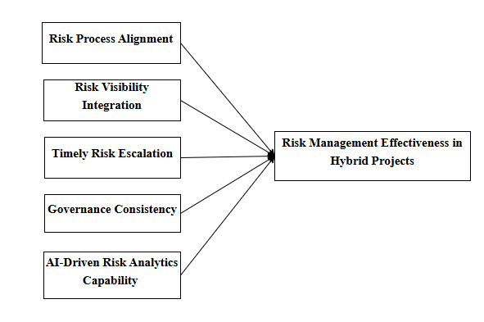
Figure 1 Conceptual Framework of AI-Driven Strategic Risk Management in Hybrid Project Environments
The conceptual framework depicted in the diagram illustrates the key factors influencing risk management effectiveness in hybrid projects. It identifies five critical dimensions: Risk Process Alignment, which ensures that risk management procedures are integrated and consistent with overall project processes; Risk Visibility Integration, which emphasizes the timely and transparent sharing of risk information across stakeholders; Timely Risk Escalation, highlighting the importance of promptly addressing emerging risks to prevent escalation; Governance Consistency, ensuring that organizational policies, standards, and decision-making structures are uniformly applied; and AI-Driven Risk Analytics Capability, reflecting the use of artificial intelligence tools to enhance risk identification, assessment, and mitigation. Collectively, these dimensions are hypothesized to positively influence the overall effectiveness of risk management in hybrid project environments, where traditional and agile practices coexist.

Sample Design
In this study, a simple random sampling method was adopted to ensure adequate and unbiased representation of professionals working in hybrid project environments, thereby providing a well-justified coverage of respondents relevant to examining the impact of AI-driven strategic risk management on risk management effectiveness. The sampling framework was designed by considering key demographic and professional parameters such as age, gender, educational qualification, years of experience, organizational role, industry type, organizational size, and level of involvement in hybrid projects, thus ensuring balanced representation across different respondent groups. Participants were selected from diverse professional roles, including project managers, risk managers, PMO professionals, agile practitioners, and IT professionals, to capture varied perspectives on risk management practices and AI adoption in hybrid project settings.
The sampling design also ensured representation across multiple industries and geographical locations within India, enhancing the diversity and generalizability of the study findings while minimizing sampling bias. The intended and achieved sample size of 384 respondents was considered statistically adequate for conducting robust statistical analyses, including Structural Equation Modelling (SEM), ensuring the reliability, validity, and generalizability of the research outcomes.

Data collection
A quantitative approach was adopted for this study, where systematic data collection procedures have been performed to ensure accuracy and reliability. In this respect, primary data have been collected through a structured questionnaire with statements containing five-point Likert-scale items, ranging from strongly disagree to strongly agree, in order to measure perceptions of risk process alignment between Agile and Waterfall methodologies, Risk Visibility Integration, Timely Risk Escalation, Governance Consistency, AI-Driven Risk Analytics Capability, Risk Management Effectiveness in Hybrid Project. The survey was administrated online using Google Forms and email and email distribution, to reach professionals actively involved in hybrid project management across various industries. In addition, secondary data from relevant academic literature, industry reports, project management standards, and published studies were reviewed to support the conceptual framework and to validate and contextualize the primary findings.

Source of data
The data for this research on the impact of AI-driven strategic risk management on risk management effectiveness in hybrid project environments were collected from both primary and secondary sources to ensure a comprehensive and multidimensional understanding of risk management practices from both empirical and theoretical practices.

Primary source:
The primary data for this research were gathered via structured questionnaires, surveys, and Google Forms.
Structured questionnaires:
Structured questionnaires were designed to systematically collect information on respondents’ perceptions of AI-driven strategic risk management practices in hybrid project environments. The questionnaire covered key dimensions such as risk process alignment between Agile and Waterfall methodologies, risk visibility integration, timely risk escalation, governance consistency, AI-driven risk analytics capability, and overall risk management effectiveness. A five-point Likert scale was employed to ensure objective and quantitatively reliable measurement of respondents’ perceptions. This structured approach enabled consistent assessment of AI-enabled risk management practices and their effectiveness in identifying, assessing, monitoring, and mitigating risks in hybrid projects
Surveys:
The survey targeted professionals involved in hybrid project environments, including project managers, risk managers, Agile practitioners, PMO professionals, and IT specialists. Data were collected using both online and offline methods to ensure adequate inclusion of respondents across different industries, organizational sizes, experience levels, and geographical regions within India. The survey design enabled comparative analysis across professional roles and levels of exposure to AI-enabled tools, allowing the study to examine variations in perceptions and implementation of AI-driven risk management practices in hybrid projects.
Google forms:
Google Forms was used to distribute the surveys and questionnaires in order to increase reach and guarantee effective data collecting. The use of digital data collection facilitated convenience and anonymity for respondents, thereby encouraging honest and unbiased responses regarding organizational risk management practices and AI adoption. To address potential limitations related to digital accessibility, offline methods, including paper-based questionnaires and direct interactions within organizations, were also employed to ensure inclusiveness and balanced representation of the study population.

Secondary Data
Secondary data were collected from peer-reviewed journals, conference proceedings, industry reports, project management standards, government publications, and professional body reports related to project management, risk management, hybrid project methodologies, and artificial intelligence adoption. These sources were used to support the conceptual framework, develop measurement constructs, and validate the findings derived from primary data. Secondary data also helped contextualize the study results by providing theoretical and empirical insights into risk management effectiveness, AI-enabled decision-making, and governance practices in hybrid project environments, thereby strengthening the overall analysis and interpretation of results.

Sampling Technique
The random sample approach was chosen in this study since it was the most efficient way to choose research participants. Every member of a population has an equal chance of being chosen for the study, according to the random sampling principle. As a result, we are certain that our results will be impartial and generalisable. This process eliminates any systematic preferences or tendencies since each person or component is chosen at random. The external validity of study findings is improved by the widespread use of random sampling, which offers an objective and equitable representation of a population. After dividing the population into these pertinent strata, it's easy to create a representative and balanced sample by selecting individuals at random from the organisations.

Inclusion and exclusion Criteria
Inclusion
- Professionals working in hybrid project environments that integrate Agile and Waterfall methodologies.
- Individuals aged 18 years and above with active involvement in project or risk management activities.
- Respondents with a minimum of one year of experience in hybrid project environments to ensure sufficient exposure to risk management practices.
- Professionals representing diverse educational backgrounds, industries, organizational sizes, experience levels, and project roles, including project managers, risk managers, PMO professionals, Agile practitioners, and IT professionals.
- Participants who, upon informed consent, voluntarily agreed to participate in the study.
Exclusion
- Individuals not involved in hybrid project environments or those working exclusively in pure Agile or pure Waterfall settings.
- Respondents with less than one year of experience in hybrid project or risk management roles, as limited exposure may affect the accuracy of responses.
- Incomplete, inconsistent, or invalid questionnaire responses that could compromise data reliability.
- Individuals who were unable to provide informed consent or who declined to participate in the study.

Measures
Data has been gathered with the help of a structured questionnaire. Questionnaire has been prepared using 5 Likert-scale (Strongly disagree to strongly agree) where respondents will be asked to share their opinions regarding various research questions under study. The Questionnaire included only closed ended items. Questions have been carefully crafted so as to gather meaningful information with respect to identified research variables. The details of the variables used for the analysis are presented below.
Variables
Risk Process Alignment
Risk process alignment refers to the degree to which risk management processes are consistently structured and integrated across different project methodologies (such as Agile and Waterfall). It involves aligning risk identification, assessment, response planning, implementation, and monitoring processes so they work coherently across hybrid project environments, enabling smoother coordination and decision-making.
Risk Visibility Integration
Risk visibility integration is the extent to which risk information is consolidated, shared, and accessible across stakeholders and project layers, enabling continuous awareness of risk exposures and facilitating timely decision-making. It includes transparent documentation, dashboards, and communication channels that integrate risk data between teams, tools, and governance structures (Schön et al., 2020).
Timely Risk Escalation
Timely risk escalation refers to the prompt reporting and escalation of risk events or triggers to appropriate decision-making levels when risks exceed predefined thresholds or require strategic intervention. This ensures that critical risks are addressed before they evolve into significant issues impacting objectives.
Governance Consistency
Governance consistency denotes the uniform application of risk governance structures, policies, roles, and decision-rights across project teams and organizational units. It includes consistent oversight mechanisms, reporting lines, and accountability for risk activities to ensure strategic alignment and compliance with organizational risk frameworks.
AI-Driven Risk Analytics Capability
AI-driven risk analytics capability refers to the organizational ability to apply artificial intelligence, machine learning, and advanced analytics methods to detect, analyse, predict, and visualize risk patterns from structured and unstructured data. This capability enhances predictive insight into future risks, automates risk detection, supports prioritization, and provides actionable recommendations.
Risk Management Effectiveness in Hybrid Projects
Risk management effectiveness in hybrid projects refers to the degree to which risk management practices successfully achieve desired outcomes minimizing negative impacts on project objectives (scope, cost, time, quality) while enabling opportunities through systematic identification, evaluation, response, monitoring, and control of risks within hybrid project environments (combined Agile and Waterfall).

Tools and techniques
Tools:
In this study SPSS (Statistical package for the social sciences) and AMOS tools are utilized.
Techniques:
Measurement model and validity
Measurement models and validity are essential to research because they give a systematic framework for ensuring that findings are accurate and meaningful. Measurement models let academics evaluate complicated ideas by clearly showing the connections between observable facts and the ideas that underlie them. On the other hand, validity guarantees that the tools employed for measurement accurately capture the desired structures, which protects against findings that are incorrect or misleading. Measurement models and validity are both important parts of research. They provide the basis for results that are credible and trustworthy, which are necessary for making informed decisions and increasing knowledge in a variety of fields.
FACTOR ANALYSIS
KMO and Bartlett's Test
The Kaiser-Meyer-Olkin (KMO) Test gauges how well your data fits into the Factor Analysis framework. The test evaluates sampling adequacy for the whole model as well as for each of the variables. The percentage of variation among variables that may represent common variance is measured by the statistic. Your data is better suited for factor analysis if the percentage is smaller.
KMO gives values in the range of 0 and 1. A general guideline for deciphering the statistic:
- KMO values in the range of 0.8 and 1 show that the sampling is sufficient.
- KMO values below 0.6 suggest that corrective action is necessary since the sample is insufficient. Use your own discretion for values between 0.5 and 0.6, since some writers have set this value at 0.5.
- Large partial correlations relative to the total of correlations are indicated by KMO values around zero. Stated differently, the prevalence of correlations poses a significant challenge to component analysis.
The KMO test formula is as follows:
- R = [r_{ij}] is the Correlation matrix,
- U = [u] is the partial covariance matrix,
- Σ = summation notation (“add up”).
The Reliability and Validity of the scale:
Ensuring the reliability and validity of the scale is crucial in research. To guarantee that the results are meaningful, the reliability and validity of the scales used in this study have been thoroughly evaluated.

Reliability
Reliability refers to the consistency of a measurement. A reliable instrument consistently produces the same results when research is repeated under identical conditions. For example, if a thermometer consistently gives the same temperature reading for a liquid under identical conditions across multiple tests, the results are considered reliable.
Factor loading
The degree of correlation between an observable variable and a latent variable is indicated by a number called the factor loading. It usually ranges from 0 to 1, however when computing many variables, certain datasets may have factor loadings larger than 1. Greater relationship with the latent variable is indicated by higher factor loadings. For instance, the latent variable of anxiety has a factor loading of 0.85 for question one and 0.33 for question two, according to a study of survey data. Question one is likely more successful than Question 2 in identifying respondents who suffer from anxiety since it has a higher factor loading. This is because question one has a larger correlation with the latent variable than question two, according to the factor loading (Team, 2024).
Cronbach’s alpha:
The Cronbach alpha coefficient method is the most commonly used to measure the reliability of a study. This coefficient ranges from 0 to 1. Many studies suggest that a minimum score of 0.6 indicates reliability, while a score above 0.7 is often regarded as high reliability. However, a reliability score in the range of 0.5 to 0.6 is acceptable in the early stages of basic research specifically at pilot study stage.
In this research, Cronbach's alpha has been used to investigate for data reliability. It is a widely used tool in marketing research. A low alpha value indicates that the items do not adequately capture the construct, while a high alpha value suggests that the research variables are well-correlated.
Average Variance Extracted
Many research has used the criteria for evaluating convergent validity in addition to looking at the standardized factor loadings. said that when a latent concept explains at least half of the variation in the indicators it is related with, convergent validity has been proven. They suggested representing the average amount of variation explained by a construct in its indicators in relation to the total variance of its indicators using the average variance extracted (AVE) (Cheung et al., 2024). Average variance extracted (AVE) value greater than 0.5
A higher value implies a better degree of reliability; AVE greater than or equal to 0.5 validates convergent validity; the average variance extracted is calculated by dividing the sum of squared loadings. AVE and CR have values between 0 and 1.
Composite Reliability (CR)
The internal consistency of scale items is measured by composite reliability. Composite reliability is defined as a measure of the observed variables' shared variance that is used as a latent construct indicator. Each construct's CR may be found by dividing the sum of squares of fully standardized factor loadings (Shrestha, 2021).
The lack of multicollinearity is shown by the correlation matrix being greater than 0.00001. It would be crucial to look for variable pairs with correlation coefficients of r > 0.8 and think about excluding them from the study if the determinant value is less than 0.00001. The threshold for item removal should be lowered until this criterion is met since a lower score may suggest that groups of three or more questions or statements have substantial inter-correlations.
Validity
Validity pertains to the accuracy of a measurement, indicating how well the results align with what they are intended to measure. In essence, it reflects the extent to which a measure truly represents the concept under consideration. In this research, Content Validity was assessed to ensure the validity of the questionnaire. Feedback from Subject Matter Experts was gathered to evaluate the appropriateness and accuracy of the measurement tool, often referred to as face validity. The scales used in this research were sourced from well-established studies, ensuring their content validity. Inputs were also sought from the research supervisor and Scrutiny Committee Members to ensure the questionnaire's completeness and accuracy. The validity was further reinforced by incorporating their feedback into the measurement tool. Additionally, the questionnaire was pre-tested with a sample group, and necessary adjustments were made based on the feedback received.
Discriminant Validity test
This validity shows that there are no superfluous items in the measurement model of a construct. By using a discrepancy measure known as Modification Indices (MI), AMOS was able to determine which items in the model were redundant. A high MI value suggests that the corresponding items are unnecessary. The measurement model could be run after the researcher removes one of the identified items. The redundant pair could also be constrained by the researcher using a "free parameter estimate." A further prerequisite for discriminant validity is that there should be no more than 0.85 correlation between exogenous constructs. When the correlation value is greater than 0.85, it means that there is a significant multicollinearity issue or that the two exogenous constructs are redundant (Awang, 2014).
Model fit summary
Model fitness aids in analyzing the mode's effectiveness. The foundation of this stage is evaluating the model's fitness using the model fit indices Chi-square value(χ²), Degrees of freedom (df), CMIN/Df, P value, GFI, RFI, NFI, CFI, IFI, RMR and RMSEA. All model indices' acceptability ranges are shown in the tables below. The model fitness of the variables is established based on the acceptance level.
A thorough assessment of the structural equation model's goodness-of-fit is given by the model fit indices. Important indices like the Goodness of Fit Index (GFI), Relative Fit Index (RFI), Normed Fit Index (NFI), Incremental Fit Index (IFI), and Comparative Fit Index (CFI) greater than or equal to 0.90 are indicators of an acceptable fit, as is a Chi-square value (χ²) relative to degrees of freedom (CMIN/DF) of less than 3.00 and a p-value below 0.05. A suitable and well-fitting model for the data is also indicated by the Root Mean Square Residual (RMR) being less than or equal to 0.05 and the Root Mean Square Error of Approximation (RMSEA) being less than or equal to 0.08.
Confirmatory Factor Analysis (CFA):
Confirmatory component Analysis (CFA) is an advanced statistical method used to validate the component structure of a collection of observed data. It enables researchers to evaluate the hypothesis that a correlation between observable variables and their underlying latent constructs is present. Confirmatory Factor Analysis (CFA) contrasts with Exploratory Factor Analysis (EFA), since the former tests a predetermined structure of the data rather than discovering it.
The main objective of CFA is to ascertain the extent to which the data aligns with a proposed measuring model derived from theoretical frameworks or previous studies. This entails many essential steps:
- Defining constructions: The method starts with the precise delineation of the theoretical constructions. At this point, researchers often pretest the elements of the construct to assess their clarity and confirm their appropriate representation of the notion.
- Formulating the Measurement Model: In Confirmatory component Analysis (CFA), researchers define the principle of one-dimensionality, whereby many observed variables exclusively assess a singular component or construct. Generally, an effective approach entails possessing a minimum of three things for each build.
- Defining the Model: Researchers must delineate the number of factors and the configuration of loadings (which variables correspond to which components). This specification is based on theoretical anticipations or outcomes from prior research.
- Evaluating Model Fit: The validity of the measurement model is determined by juxtaposing the theoretical model with the empirical data. This entails analyzing factor loadings (with a typical threshold of 0.7 or above for sufficient loadings) and fit indices like Chi-square, Root Mean Square Error of Approximation (RMSEA), Goodness of Fit Index (GFI), and Comparative Fit Index (CFI).
Hypothesis test
SEM (structural equational modelling)
Structural equation modelling (SEM) is a versatile statistical tool that is used to describe complex connections between variables, regardless of whether such interactions are obvious or latent. It offers a variety of unique qualities, including as the ability to analyse complicated causal pathways, integrate latent components, test numerous hypotheses at the same time, take measurement error into account, evaluate model fit, and combine aspects of factor analysis and regression. Structural equation modelling (SEM) is a valuable research tool that may be used in a variety of subjects, including sociology, economics, and psychology. It is useful for evaluating theoretical models, investigating the implications of interventions or policies, and simplifying difficult datasets. This allows for a more thorough and precise analysis of the data, as well as the testing of our hypothesis.

Summary
This chapter has outlined the research methodology that was adopted for analysing the impact of AI-driven strategic risk management on risk management effectiveness in hybrid project environments. A quantitative approach was adopted, using a cross-sectional survey conducted on 384 professionals including project managers, risk managers, PMO professionals, and Agile practitioners. Data were collected primarily through structured questionnaires distributed via online forms such as Google Forms, with some offline methods to ensure wider participation. The sampling was random and included respondents from diverse industries, roles, and experience levels to reduce bias. Measurements were taken using five-point Likert scales, and secondary data from academic journals, industry reports, and professional publications were also used to support the research. Data analysis was performed using SPSS and AMOS, including factor analysis, reliability and validity tests, and SEM to evaluate relationships between key variables such as risk process alignment, risk visibility integration, timely risk escalation, governance consistency, and AI-driven risk analytics capability.

CHAPTER-4

Results

Demographics
Table 2 Demographic Variables
Variable | Category | Frequency | Percent (%)
Gender | Male | 177 | 46.1
 | Female | 207 | 53.9
 | Total | 384 | 100
Age | 20–25 Years | 68 | 17.7
 | 26–35 Years | 87 | 22.7
 | 36–45 Years | 75 | 19.5
 | 46–55 Years | 60 | 15.6
 | Above 56 Years | 94 | 24.5
 | Total | 384 | 100
Educational Qualification | Diploma | 97 | 25.3
 | Bachelor’s Degree | 96 | 25
 | Master’s Degree | 85 | 22.1
 | Professional Certification | 106 | 27.6
 | Total | 384 | 100
Project Management Experience | Less than 5 years | 86 | 22.4
 | 5–10 years | 116 | 30.2
 | 11–15 years | 89 | 23.2
 | More than 15 years | 93 | 24.2
 | Total | 384 | 100
Current Role in Project Environment | Project Manager | 86 | 22.4
 | Program/Portfolio Manager | 73 | 19
 | Risk Manager | 70 | 18.2
 | Business Analyst | 82 | 21.4
 | Team Lead / Scrum Master | 73 | 19
 | Total | 384 | 100
Primary Project Methodology Experience | Agile | 124 | 32.3
 | Waterfall | 136 | 35.4
 | Hybrid (Agile + Waterfall) | 124 | 32.3
 | Total | 384 | 100
Extent of AI Usage in Project Risk Management | Not Used | 136 | 35.4
 | Limited Use | 123 | 32
 | Moderate Use | 125 | 32.6
 | Total | 384 | 100

Gender
The gender distribution indicates a relatively balanced sample, with 177 male respondents (46.1%) and 207 female respondents (53.9%). The near-equitable representation enhances the inclusiveness of the study and minimizes potential gender-related bias in perceptions regarding AI-driven strategic risk management practices. This balance strengthens the generalizability of findings across diverse project environments.
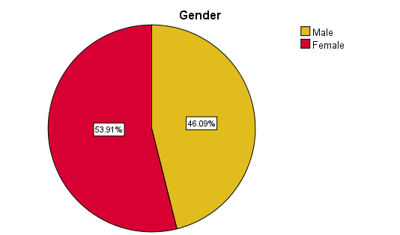
Age Group
In terms of age distribution, the sample reflects a broad spectrum of professional maturity. Respondents aged 26–35 years constitute 22.7%, followed by 36–45 years (19.5%), 20–25 years (17.7%), 46–55 years (15.6%), and above 56 years (24.5%). Notably, a substantial proportion of respondents fall within mid-career and senior age brackets, indicating that the study captures insights from both emerging professionals and highly experienced project practitioners. This diversity enhances the credibility of responses related to governance consistency and AI-enabled risk analytics capability.
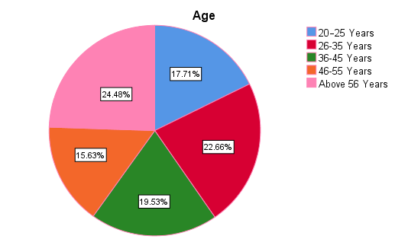
Educational Qualification
The educational profile reflects a well-qualified respondent base. Professional certifications represent the largest category (27.6%), followed by Diploma holders (25.3%), Bachelor’s degree holders (25.0%), and Master’s degree holders (22.1%). The distribution indicates that respondents possess both academic knowledge and professional specialization relevant to project management and AI adoption. The presence of professionally certified participants particularly strengthens the reliability of responses concerning strategic risk alignment and AI implementation practices.
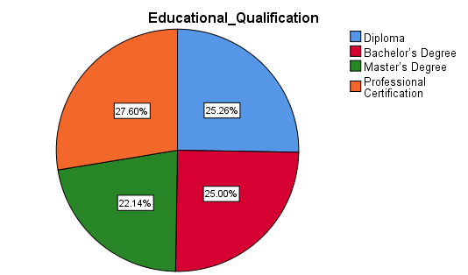
Current Role in Project Environment
With respect to professional roles, Project Managers constitute 22.4% of the sample, followed by Business Analysts (21.4%), Program/Portfolio Managers (19.0%), Team Leads/Scrum Masters (19.0%), and Risk Managers (18.2%). This balanced distribution ensures representation from both strategic leadership positions and operational management roles. The presence of senior project and portfolio managers enhances the validity of responses regarding governance structures, while Scrum Masters and Business Analysts contribute operational-level insights into risk process alignment and visibility integration.

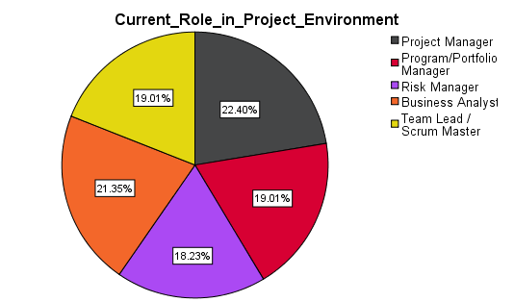
Years of Project Management Experience
The experience distribution demonstrates strong professional maturity within the sample. Respondents with 5–10 years of experience represent the largest group (30.2%), followed by those with more than 15 years (24.2%), 11–15 years (23.2%), and less than 5 years (22.4%). Overall, more than 77% of respondents possess over five years of project management experience, indicating that the findings are predominantly informed by professionals with substantial exposure to hybrid project environments and risk governance practices.

Primary Project Methodology Experience
Regarding methodology exposure, 35.4% of respondents report primary experience in Waterfall projects, while 32.3% report Agile experience and an equal 32.3% indicate Hybrid (Agile + Waterfall) experience. The relatively even distribution across methodologies is particularly relevant to this study, as it ensures that insights are derived from professionals familiar with structured, adaptive, and integrated project environments
.
Extent of AI Usage in Project Risk Management
In terms of AI usage, 35.4% of respondents report that AI is not currently used in project risk management within their organizations. Meanwhile, 32.0% report limited use, and 32.6% report moderate use. This distribution indicates that while AI adoption is progressing, it is not yet universally mature across organizations. The presence of varying levels of AI implementation strengthens the study by capturing perspectives from both early-stage adopters and more advanced users of AI-driven risk analytics.

Table 3 Descriptive Statistics of Study Variables
Variables | N | Mean | Skewness | Kurtosis
risk process alignment | 384 | 3.6073 | -0.84 | 0.815
Risk visibility integration | 384 | 3.5500 | -0.753 | 0.278
Timely risk escalation | 384 | 3.6646 | -0.948 | 0.768
Governance consistency | 384 | 3.6962 | -0.807 | 0.802
AI driven risk analytics capability | 384 | 3.6703 | -0.826 | 0.635
risk management effectiveness in hybrid project | 384 | 3.4573 | -0.425 | 0.389

The descriptive statistics presented in Table 3 summarize the central tendency and distributional characteristics of the key study variables based on a sample of 384 respondents. Overall, the mean values indicate a moderately high level of agreement across all constructs, suggesting that respondents generally perceive risk management practices and AI-enabled capabilities to be present to a reasonable extent within hybrid project environments.
Governance consistency (Mean = 3.6962) and AI-driven risk analytics capability (Mean = 3.6703) exhibit the highest mean scores among the variables, indicating that respondents perceive governance structures and AI-enabled analytical support as relatively well established in their project contexts. Timely risk escalation (Mean = 3.6646) and risk process alignment (Mean = 3.6073) also show comparatively high mean values, reflecting positive perceptions of coordination and responsiveness in managing project risks. Risk visibility integration (Mean = 3.5500) demonstrates a slightly lower mean, suggesting that while risk information is generally accessible, there may still be challenges related to full transparency or integration across hybrid project structures. Risk management effectiveness in hybrid projects records the lowest mean value (Mean = 3.4573), indicating that although governance mechanisms and capabilities are present, their translation into consistently effective risk outcomes may be uneven.
The skewness values for all variables are negative, ranging from −0.425 to −0.948, indicating a left-skewed distribution. This suggests that responses are clustered toward the higher end of the Likert scale, with relatively fewer low ratings. Such a pattern is common in organizational perception studies and reflects generally favorable respondent evaluations of risk management practices and AI capabilities. Importantly, none of the skewness values exceed the commonly accepted threshold of ±2, indicating no severe departure from normality.
Similarly, the kurtosis values range between 0.278 and 0.815, all well within acceptable limits (±3), suggesting that the distributions do not exhibit excessive peakedness or flatness. This indicates that the data approximate a normal distribution and are suitable for subsequent multivariate analysis, including structural equation modeling.
Overall, the descriptive statistics confirm that the dataset demonstrates acceptable distributional properties and that respondents report relatively positive perceptions of governance consistency, process alignment, and AI-driven risk analytics within hybrid projects. These findings provide a sound empirical basis for proceeding with confirmatory factor analysis and hypothesis testing using SEM.

Figure 2 Descriptive Statistics of Study Variables

  - Measurement Model and Validity
Measurement models and validity are indispensable in research as they establish a structured framework for ensuring the accuracy and meaningfulness of data. Measurement models clarify the relationships between observed variables and their underlying constructs, enabling researchers to assess complex concepts. Validity, on the other hand, ensures that the measurement instruments precisely capture the intended constructs, safeguarding against misleading or incorrect conclusions. Both measurement models and validity are essential components in research, serving as the foundation for reliable and credible findings, which is paramount for informed decision-making and advancing knowledge across diverse field.
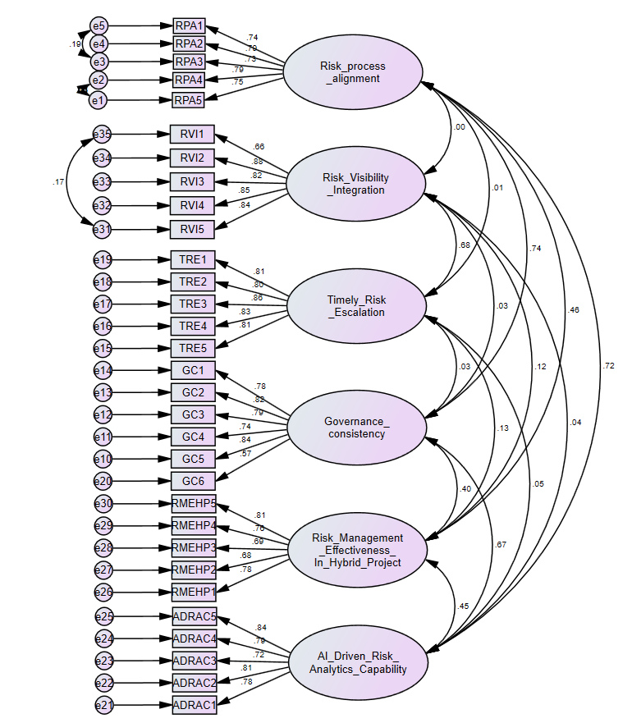

Table 4 Factor Loadings from Confirmatory Factor Analysis (CFA)
Path |  |  | Standardized Estimate | S.E. | C.R. | P
RPA5 | <--- | Risk process alignment | 0.747
RPA4 | <--- | Risk process alignment | 0.794 | 0.06 | 16.668 | ***
RPA3 | <--- | Risk process alignment | 0.733 | 0.069 | 13.628 | ***
RPA2 | <--- | Risk process alignment | 0.794 | 0.064 | 14.89 | ***
RPA1 | <--- | Risk process alignment | 0.738 | 0.078 | 13.72 | ***
GC5 | <--- | Governance consistency | 0.839
GC4 | <--- | Governance consistency | 0.739 | 0.052 | 16.383 | ***
GC3 | <--- | Governance consistency | 0.794 | 0.054 | 18.179 | ***
GC2 | <--- | Governance consistency | 0.822 | 0.052 | 19.111 | ***
GC1 | <--- | Governance consistency | 0.78 | 0.055 | 17.712 | ***
TRE5 | <--- | Timely Risk Escalation | 0.814
TRE4 | <--- | Timely Risk Escalation | 0.834 | 0.056 | 18.866 | ***
TRE3 | <--- | Timely Risk Escalation | 0.86 | 0.063 | 19.685 | ***
TRE2 | <--- | Timely Risk Escalation | 0.804 | 0.059 | 17.933 | ***
TRE1 | <--- | Timely Risk Escalation | 0.81 | 0.057 | 18.104 | ***
GC6 | <--- | Governance consistency | 0.565 | 0.06 | 11.613 | ***
ADRAC1 | <--- | AI Driven Risk Analytics Capability | 0.776
ADRAC2 | <--- | AI Driven Risk Analytics Capability | 0.808 | 0.064 | 16.66 | ***
ADRAC3 | <--- | AI Driven Risk Analytics Capability | 0.72 | 0.065 | 14.537 | ***
ADRAC4 | <--- | AI Driven Risk Analytics Capability | 0.791 | 0.062 | 16.247 | ***
ADRAC5 | <--- | AI Driven Risk Analytics Capability | 0.842 | 0.063 | 17.479 | ***
RMEHP1 | <--- | Risk Management Effectiveness In Hybrid Project | 0.776
RMEHP2 | <--- | Risk Management Effectiveness In Hybrid Project | 0.685 | 0.063 | 13.225 | ***
RMEHP3 | <--- | Risk Management Effectiveness In Hybrid Project | 0.688 | 0.06 | 13.301 | ***
RMEHP4 | <--- | Risk Management Effectiveness In Hybrid Project | 0.756 | 0.062 | 14.729 | ***
RMEHP5 | <--- | Risk Management Effectiveness In Hybrid Project | 0.809 | 0.063 | 15.809 | ***
RVI5 | <--- | Risk Visibility Integration | 0.844
RVI4 | <--- | Risk Visibility Integration | 0.849 | 0.052 | 20.494 | ***
RVI3 | <--- | Risk Visibility Integration | 0.823 | 0.049 | 19.5 | ***
RVI2 | <--- | Risk Visibility Integration | 0.884 | 0.049 | 21.806 | ***
RVI1 | <--- | Risk Visibility Integration | 0.657 | 0.059 | 15.329 | ***

Table 5 KMO and Bartlett's Test

KMO and Bartlett's Test
Kaiser-Meyer-Olkin Measure of Sampling Adequacy. |  | .927
Bartlett's Test of Sphericity | Approx. Chi-Square | 7618.445
 | df | 465
 | Sig. | .000

KMO and Bartlett's tests to assess the suitability for factor analysis. The obtained KMO value was 0.927, indicating high sampling adequacy, and the Bartlett's test was highly significant (P = 0.00), supporting the factor analysis.
Table 6 Convergent Validity Assessment (AVE and Composite Reliability)
Variables | AVE | CR
Risk process alignment | 0.761 | 0.858
Risk Visibility Integration | 0.811 | 0.873
Timely Risk Escalation | 0.824 | 0.877
Governance consistency | 0.757 | 0.880
AI Driven Risk Analytics Capability | 0.787 | 0.866
Risk Management Effectiveness in Hybrid Project | 0.743 | 0.852

Discriminant Validity
Discriminant validity is not a specific test performed in SPSS or any other statistical software but a concept within the context of validating measurement instruments and assessing the relationships between variables. Discriminant validity is crucial to ensure that different constructs or variables in a study are truly distinct and not measuring the same underlying concept. Researchers use various techniques such as confirmatory factor analysis (CFA) or correlation analysis to demonstrate that the measures intended to assess different constructs are, indeed, different and not highly correlated. Discriminant validity helps ensure that the measurement instruments accurately represent the unique concepts they are meant to measure, preventing construct overlap or redundancy and allowing for more robust and accurate data analysis and interpretation.
Table 7 Discriminant Validity Matrix (Fornell-Larcker Criterion)
 | Risk process alignment | Risk Visibility Integration | Timely Risk Escalation | Governance consistency | AI Driven Risk Analytics Capability | Risk Management Effectiveness in Hybrid Project
Risk process alignment | 0.872
Risk Visibility Integration | -0.001 | 0.900
Timely Risk Escalation | 0.006 | .629** | 0.908
Governance consistency | .671** | 0.027 | 0.030 | 0.870
AI Driven Risk Analytics Capability | .633** | 0.041 | 0.047 | .602** | 0.887
Risk Management Effectiveness in Hybrid Project | .404** | 0.098 | .122* | .368** | .405** | 0.861

Model Fit Summary
Table 8 Overall Model Fit Indices for Measurement Model
Variable | Value
Chi-square value(χ²) | 661.788
Degrees of freedom (df) | 416
CMIN/DF | 1.591
P value | 0
GFI | 0.901
RFI | 0.906
NFI | 0.916
IFI | 0.967
CFI | 0.967
RMR | 0.39
RMSEA | 0.39

SEM (Structural Equational Modelling)
Structural Equation Modelling (SEM), a flexible statistical approach, to describe complex interactions between variables, whether latent or observable. Its ability to analyse intricate causal pathways, integrate latent components, test several hypotheses at once, account for measurement error, evaluate model fit, and combine aspects of factor analysis and regression are just a few of its special features. SEM is an essential tool for research in disciplines like psychology, sociology, economics, and beyond because it can be used to validate theoretical models, examine the effects of interventions or policies, and simplify complex datasets. This allows for more thorough and accurate data analysis and hypothesis testing.

Proposed Hypothesis

Hypothesis 1
H1: Risk Process Alignment has a significant positive impact on Risk Management Effectiveness in Hybrid Project Environments.
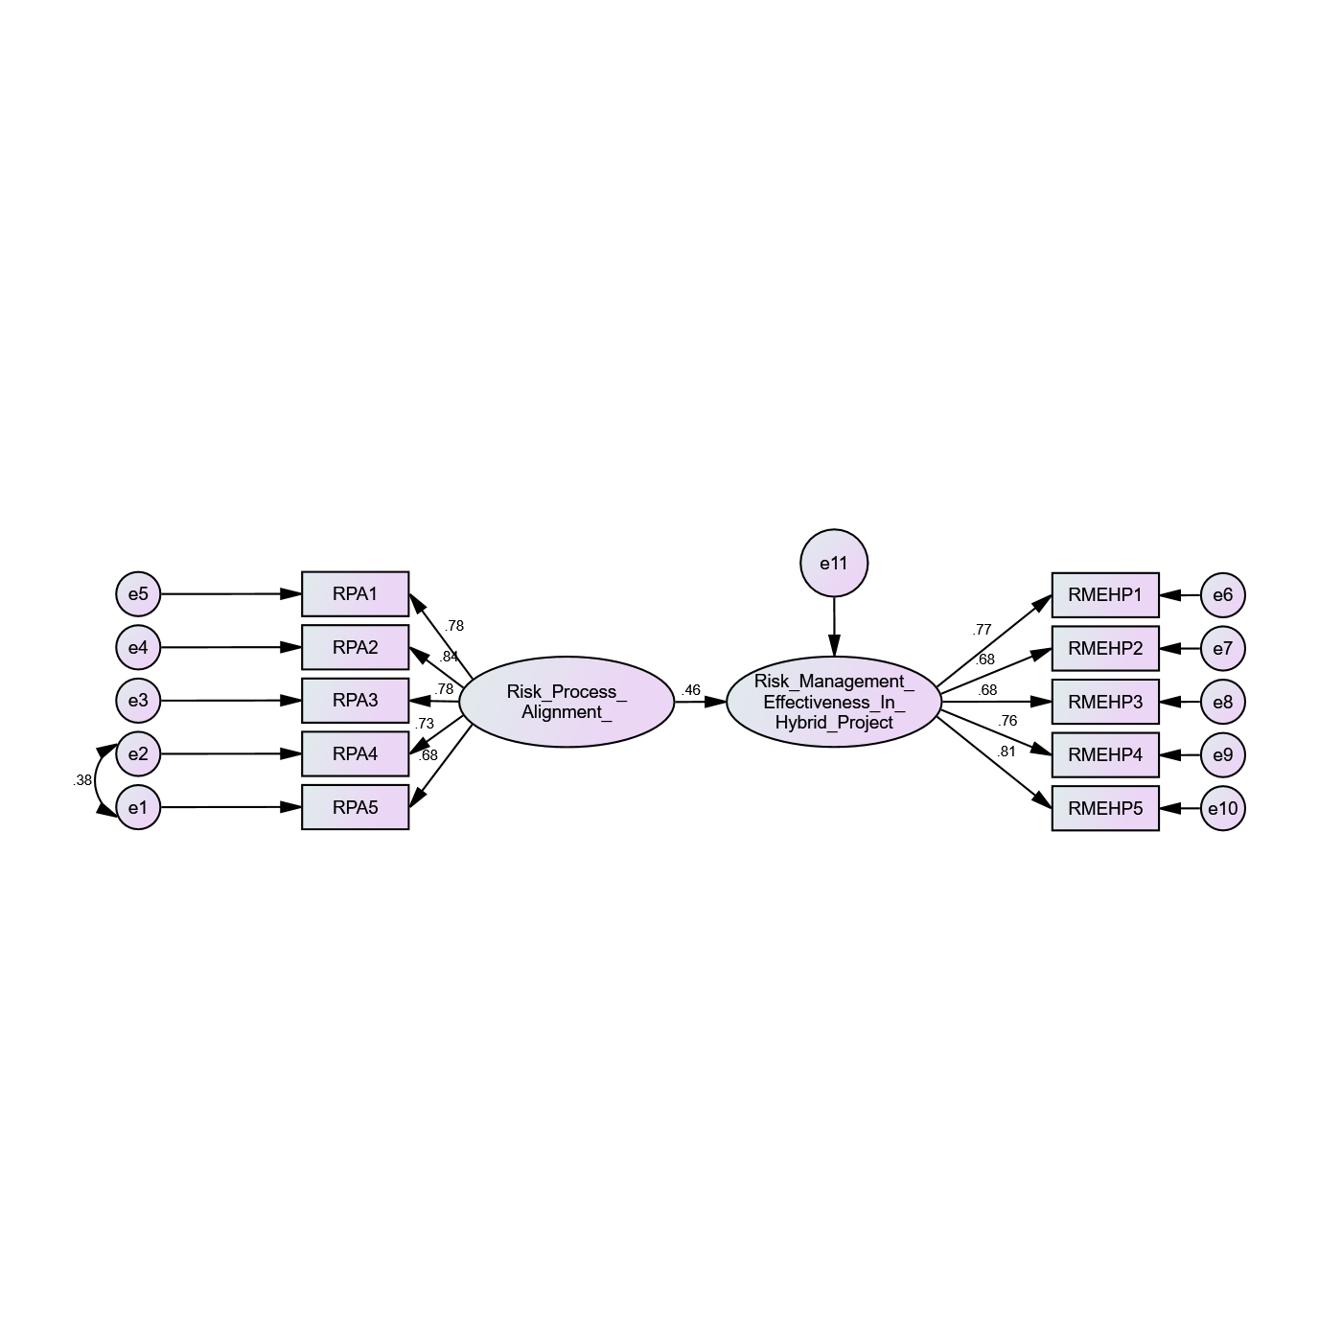
To examine Hypothesis 1, Structural Equation Modelling (SEM) was conducted using AMOS to assess the direct relationship between Risk Process Alignment and Risk Management Effectiveness in Hybrid Projects. The results presented in Table 2 (Regression Weights: Group number 1 – Default model) indicate that Risk Process Alignment has a statistically significant and positive effect on Risk Management Effectiveness (Standardized Estimate = 0.464, S.E. = 0.069, C.R. = 7.346, p < 0.001). The standardized coefficient of 0.464 reflects a moderate and meaningful positive relationship, suggesting that improved alignment of risk management processes across Agile and Waterfall methodologies substantially enhances overall risk management effectiveness in hybrid project environments. The critical ratio (C.R. = 7.346), which exceeds the threshold of 1.96, further confirms the statistical significance of the relationship. Therefore, the null hypothesis (H01) is rejected, and Hypothesis 1 is supported.
Table 10 Regression Weights: (Group number 1 - Default model)
Path |  |  | Standardized Estimate | S.E. | C.R. | P
Risk Management Effectiveness in Hybrid Project | <--- | Risk process alignment | 0.464 | 0.069 | 7.346 | ***
RPA1 | <--- | Risk process alignment | 0.676
RPA2 | <--- | Risk process alignment | 0.726 | 0.063 | 15.892 | ***
RPA3 | <--- | Risk process alignment | 0.783 | 0.084 | 13.137 | ***
RPA4 | <--- | Risk process alignment | 0.84 | 0.08 | 13.792 | ***
RPA5 | <--- | Risk process alignment | 0.781 | 0.095 | 13.104 | ***
RMEHP1 | <--- | Risk Management Effectiveness in Hybrid Project | 0.773
RMEHP2 | <--- | Risk Management Effectiveness in Hybrid Project | 0.684 | 0.064 | 13.158 | ***
RMEHP3 | <--- | Risk Management Effectiveness in Hybrid Project | 0.684 | 0.061 | 13.144 | ***
RMEHP4 | <--- | Risk Management Effectiveness in Hybrid Project | 0.76 | 0.062 | 14.726 | ***
RMEHP5 | <--- | Risk Management Effectiveness in Hybrid Project | 0.812 | 0.063 | 15.744 | ***

In addition to the structural relationship, the measurement properties of the constructs were also examined. As shown in Table 2, the factor loadings for the Risk Process Alignment indicators (RPA1–RPA5) range from 0.676 to 0.840, all exceeding the recommended minimum threshold of 0.60, thereby confirming satisfactory indicator reliability and construct representation. Similarly, the factor loadings for Risk Management Effectiveness in Hybrid Projects (RMEHP1–RMEHP5) range from 0.684 to 0.812, demonstrating strong convergence of observed variables on their respective latent construct. These loadings indicate that the measurement model adequately captures the underlying theoretical dimensions of both constructs, supporting convergent validity.
Table 11 Model Fit Summary
Fit Index | Value
Chi-square (χ²) | 78.092
Degrees of Freedom (df) | 33
CMIN/DF | 2.366
P-value | 0.000
GFI | 0.958
RMR | 0.027
NFI | 0.959
RFI | 0.945
IFI | 0.976
CFI | 0.976
RMSEA | 0.060

The overall goodness-of-fit statistics for the structural model are presented in Table 3 (Model Fit Summary). The Chi-square value (χ² = 78.092) with 33 degrees of freedom yields a CMIN/DF ratio of 2.366, which falls within the acceptable range of less than 3.00, indicating an adequate model fit. Although the p-value is significant (p = 0.000), this outcome is common in large samples and does not necessarily indicate poor fit. Additional fit indices further confirm model adequacy: GFI = 0.958, NFI = 0.959, IFI = 0.976, and CFI = 0.976, all exceeding the recommended threshold of 0.90. The RMSEA value of 0.060 is below the acceptable upper limit of 0.08, and the RMR value of 0.027 is within acceptable standards, indicating minimal residual error. Collectively, these indices demonstrate that the proposed structural model provides a good representation of the observed data.
The findings therefore indicate that when risk identification, assessment, monitoring, and response processes are systematically aligned across Agile and Waterfall components within hybrid projects, organizations experience improved coordination, reduced ambiguity, and enhanced responsiveness to emerging uncertainties. Risk Process Alignment ensures consistency in risk documentation, escalation pathways, and accountability mechanisms, thereby strengthening the overall effectiveness of risk governance structures. In hybrid environments where methodological fragmentation can create procedural gaps process alignment appears to function as a foundational enabler of effective risk management performance.
Based on the statistical significance of the path coefficient, the strength of the standardized estimate, and the satisfactory model fit indices reported in Table 3, Hypothesis 1 is accepted. The results confirm that Risk Process Alignment is a key determinant of Risk Management Effectiveness in Hybrid Project Environments.

Hypothesis 2
H2: Risk Visibility Integration has a significant positive impact on Risk Management Effectiveness in Hybrid Project Environments.
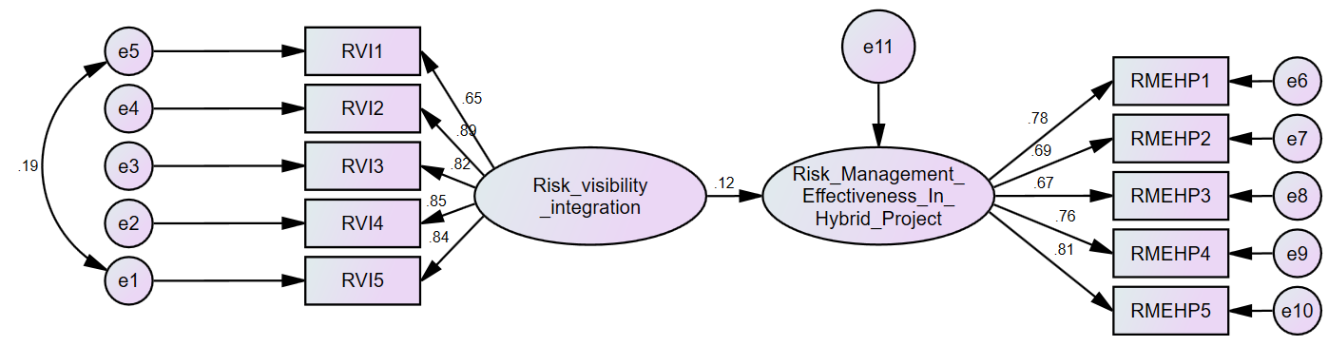
Table 11 Regression Weights: (Group number 1 - Default model)
Path |  |  | Standardized Estimate | S.E. | C.R. | P
Risk Management Effectiveness In Hybrid Project | <--- | Risk visibility integration | 0.121 | 0.059 | 2.116 | 0.034
RVI5 | <--- | Risk visibility integration | 0.843
RVI4 | <--- | Risk visibility integration | 0.847 | 0.053 | 20.221 | ***
RVI3 | <--- | Risk visibility integration | 0.825 | 0.049 | 19.43 | ***
RVI2 | <--- | Risk visibility integration | 0.887 | 0.05 | 21.632 | ***
RVI1 | <--- | Risk visibility integration | 0.65 | 0.06 | 15.143 | ***
RMEHP1 | <--- | Risk Management Effectiveness In Hybrid Project | 0.779
RMEHP2 | <--- | Risk Management Effectiveness In Hybrid Project | 0.689 | 0.063 | 13.278 | ***
RMEHP3 | <--- | Risk Management Effectiveness In Hybrid Project | 0.669 | 0.06 | 12.853 | ***
RMEHP4 | <--- | Risk Management Effectiveness In Hybrid Project | 0.759 | 0.062 | 14.753 | ***
RMEHP5 | <--- | Risk Management Effectiveness In Hybrid Project | 0.814 | 0.063 | 15.815 | ***
Table 11 presents the standardized regression weights obtained from the Structural Equation Modelling (SEM) analysis examining the relationship between Risk Visibility Integration and Risk Management Effectiveness in Hybrid Projects, along with the measurement loadings of their respective indicators.
The results indicate that Risk Visibility Integration has a positive and statistically significant effect on Risk Management Effectiveness in Hybrid Project Environments (β = 0.121, C.R. = 2.116, p = 0.034). Therefore, H2 is supported. The structural path from Risk Visibility Integration to Risk Management Effectiveness in Hybrid Projects is positive and statistically significant (β = 0.121, S.E. = 0.059, C.R. = 2.116, p = 0.034). The critical ratio exceeds the recommended threshold of 1.96, and the p-value is below 0.05, indicating that increased integration of risk visibility mechanisms contributes significantly to improvements in risk management effectiveness in hybrid project environments. However, the magnitude of the standardized coefficient suggests a modest effect size, implying that Risk Visibility Integration exerts a supportive rather than dominant influence.
The measurement indicators for Risk Visibility Integration (RVI1–RVI5) demonstrate strong standardized factor loadings, ranging from 0.650 to 0.887. All loadings exceed the minimum acceptable threshold of 0.60 and are statistically significant (p < 0.001), indicating that the observed variables reliably capture the underlying construct. Among the indicators, RVI2 and RVI4 exhibit the highest loadings, reflecting their strong contribution to the construct.
Similarly, the indicators measuring Risk Management Effectiveness in Hybrid Projects (RMEHP1–RMEHP5) show satisfactory standardized loadings ranging from 0.669 to 0.814, with all paths achieving high statistical significance (p < 0.001). These results confirm adequate convergent validity and internal consistency for the dependent construct.
Overall, the table demonstrates that both constructs are well-measured and statistically robust, and that Risk Visibility Integration has a significant but relatively limited direct effect on Risk Management Effectiveness in Hybrid Project environments. The findings suggest that while visibility of risk information is important, its effectiveness is likely enhanced when combined with complementary organizational and governance mechanisms.
Table 12 Model Fit Summary
Fit Index | Value
Chi-square (χ²) | 45.405
Degrees of Freedom (df) | 33
CMIN/DF | 1.376
P-value | 0.047
NFI | 0.978
RFI | 0.971
IFI | 0.994
CFI | 0.994
RMSEA | 0.031

Table 12 presents the model fit indices for the structural equation model assessing the relationship between Risk Visibility Integration and Risk Management Effectiveness in Hybrid Project Environments. The Chi-square statistic is χ² = 45.405 with 33 degrees of freedom, resulting in a CMIN/DF ratio of 1.376, which is well below the recommended threshold of 3.00 and indicates a good overall model fit. Although the associated p-value (0.047) is marginally below 0.05, this outcome is acceptable given the known sensitivity of the Chi-square statistic to sample size and model complexity.
Additional incremental and comparative fit indices further confirm the adequacy of the model. The Normed Fit Index (NFI = 0.978) and Relative Fit Index (RFI = 0.971) both exceed the recommended cutoff value of 0.90, indicating strong comparative fit relative to the null model. Similarly, the Incremental Fit Index (IFI = 0.994) and Comparative Fit Index (CFI = 0.994) demonstrate excellent fit, approaching the ideal value of 1.00.
The Root Mean Square Error of Approximation (RMSEA = 0.031) indicates a close approximate fit to the data and is well below the commonly accepted threshold of 0.08, further supporting the robustness of the model. Collectively, these fit indices demonstrate that the proposed structural model provides a very good representation of the observed data, confirming its suitability for hypothesis testing.

Hypothesis 3
H3: Timely Risk Escalation has a significant positive impact on Risk Management Effectiveness in Hybrid Project Environments.
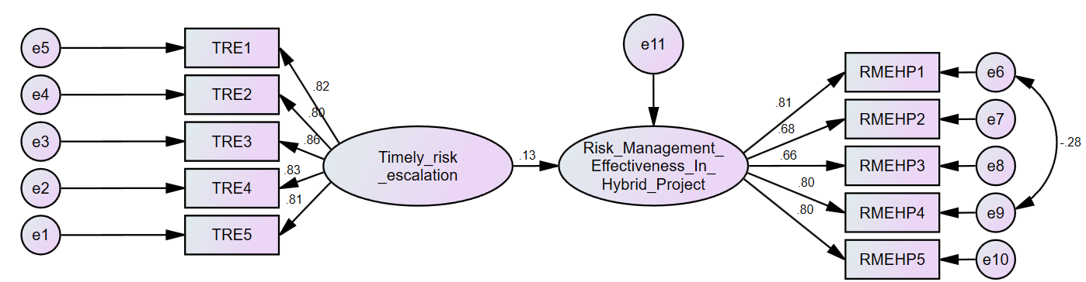
Table 13 Regression Weights: (Group number 1 - Default model)
Path |  |  | Standardized Estimate | S.E. | C.R. | P
Risk Management Effectiveness In Hybrid Project | <--- | Timely risk escalation | 0.129 | 0.129 | 2.283 | 0.022
TRE5 | <--- | Timely risk escalation | 0.81 | 0.81
TRE4 | <--- | Timely risk escalation | 0.832 | 0.832 | 18.558 | ***
TRE3 | <--- | Timely risk escalation | 0.865 | 0.865 | 19.552 | ***
TRE2 | <--- | Timely risk escalation | 0.798 | 0.798 | 17.533 | ***
TRE1 | <--- | Timely risk escalation | 0.817 | 0.817 | 18.096 | ***
RMEHP1 | <--- | Risk Management Effectiveness In Hybrid Project | 0.814 | 0.814
RMEHP2 | <--- | Risk Management Effectiveness In Hybrid Project | 0.676 | 0.676 | 13.081 | ***
RMEHP3 | <--- | Risk Management Effectiveness In Hybrid Project | 0.663 | 0.663 | 12.813 | ***
RMEHP4 | <--- | Risk Management Effectiveness In Hybrid Project | 0.796 | 0.796 | 14.561 | ***
RMEHP5 | <--- | Risk Management Effectiveness In Hybrid Project | 0.795 | 0.795 | 15.335 | ***

Table 13 reports the standardized regression weights for the structural relationship between Timely Risk Escalation and Risk Management Effectiveness in Hybrid Projects, along with the factor loadings of their respective measurement indicators.
The structural path from Timely Risk Escalation to Risk Management Effectiveness in Hybrid Projects is positive and statistically significant, with a standardized coefficient of β = 0.129, a standard error of 0.129, a critical ratio (C.R.) of 2.283, and a p-value of 0.022. Since the critical ratio exceeds the threshold of 1.96 and the p-value is below 0.05, the results indicate that timely escalation of risks has a significant influence on improving risk management effectiveness in hybrid project environments. Although the effect size is modest, the positive direction suggests that proactive and prompt escalation mechanisms contribute meaningfully to effective risk handling.
The measurement indicators for Timely Risk Escalation (TRE1–TRE5) demonstrate strong standardized factor loadings, ranging from 0.798 to 0.865. All indicators exceed the recommended minimum threshold of 0.60 and are statistically significant (p < 0.001), confirming strong convergent validity and reliability of the construct. Among these indicators, TRE3 exhibits the highest loading, indicating its substantial contribution to the measurement of timely risk escalation.
Similarly, the indicators measuring Risk Management Effectiveness in Hybrid Projects (RMEHP1–RMEHP5) show satisfactory standardized loadings ranging from 0.663 to 0.814, with all paths achieving high statistical significance (p < 0.001). These values confirm adequate internal consistency and construct validity for the dependent variable.
Overall, the results indicate that Timely Risk Escalation is a well-measured construct and a statistically significant predictor of Risk Management Effectiveness in hybrid project environments. While the direct impact is moderate, the findings underscore the importance of early identification and prompt escalation of risks as a key enabler of effective risk management practices
Table 14 Model Fit Summary
Fit Index | Value
Chi-square (χ²) | 43.757
Degrees of Freedom (df) | 33
CMIN/DF | 1.326
P-value | 0.036
NFI | 0.979
RFI | 0.972
IFI | 0.995
CFI | 0.995
RMSEA | 0.029

Table 14 presents the goodness-of-fit indices for the structural equation model examining the effect of Timely Risk Escalation on Risk Management Effectiveness in Hybrid Project Environments. The Chi-square statistic (χ² = 43.757) with 33 degrees of freedom yields a CMIN/DF ratio of 1.326, which is well below the recommended upper limit of 3.00, indicating a good overall fit between the proposed model and the observed data. Although the p-value (0.036) is slightly below the conventional 0.05 threshold, this result is acceptable given the sensitivity of the Chi-square statistic to sample size.
The incremental and comparative fit indices further confirm the adequacy of the model. The Normed Fit Index (NFI = 0.979) and Relative Fit Index (RFI = 0.972) both exceed the recommended cutoff value of 0.90, indicating strong improvement over the null model. Similarly, the Incremental Fit Index (IFI = 0.995) and Comparative Fit Index (CFI = 0.995) demonstrate excellent model fit, approaching the ideal value of 1.00.
The Root Mean Square Error of Approximation (RMSEA = 0.029) indicates a close approximate fit and is well below the commonly accepted threshold of 0.08, further supporting the robustness of the structural model. Collectively, these fit indices demonstrate that the proposed model provides a very good representation of the observed data and is suitable for hypothesis testing.

Hypothesis 4
H4: Governance Consistency has a significant positive impact on Risk Management Effectiveness in Hybrid Project Environments.
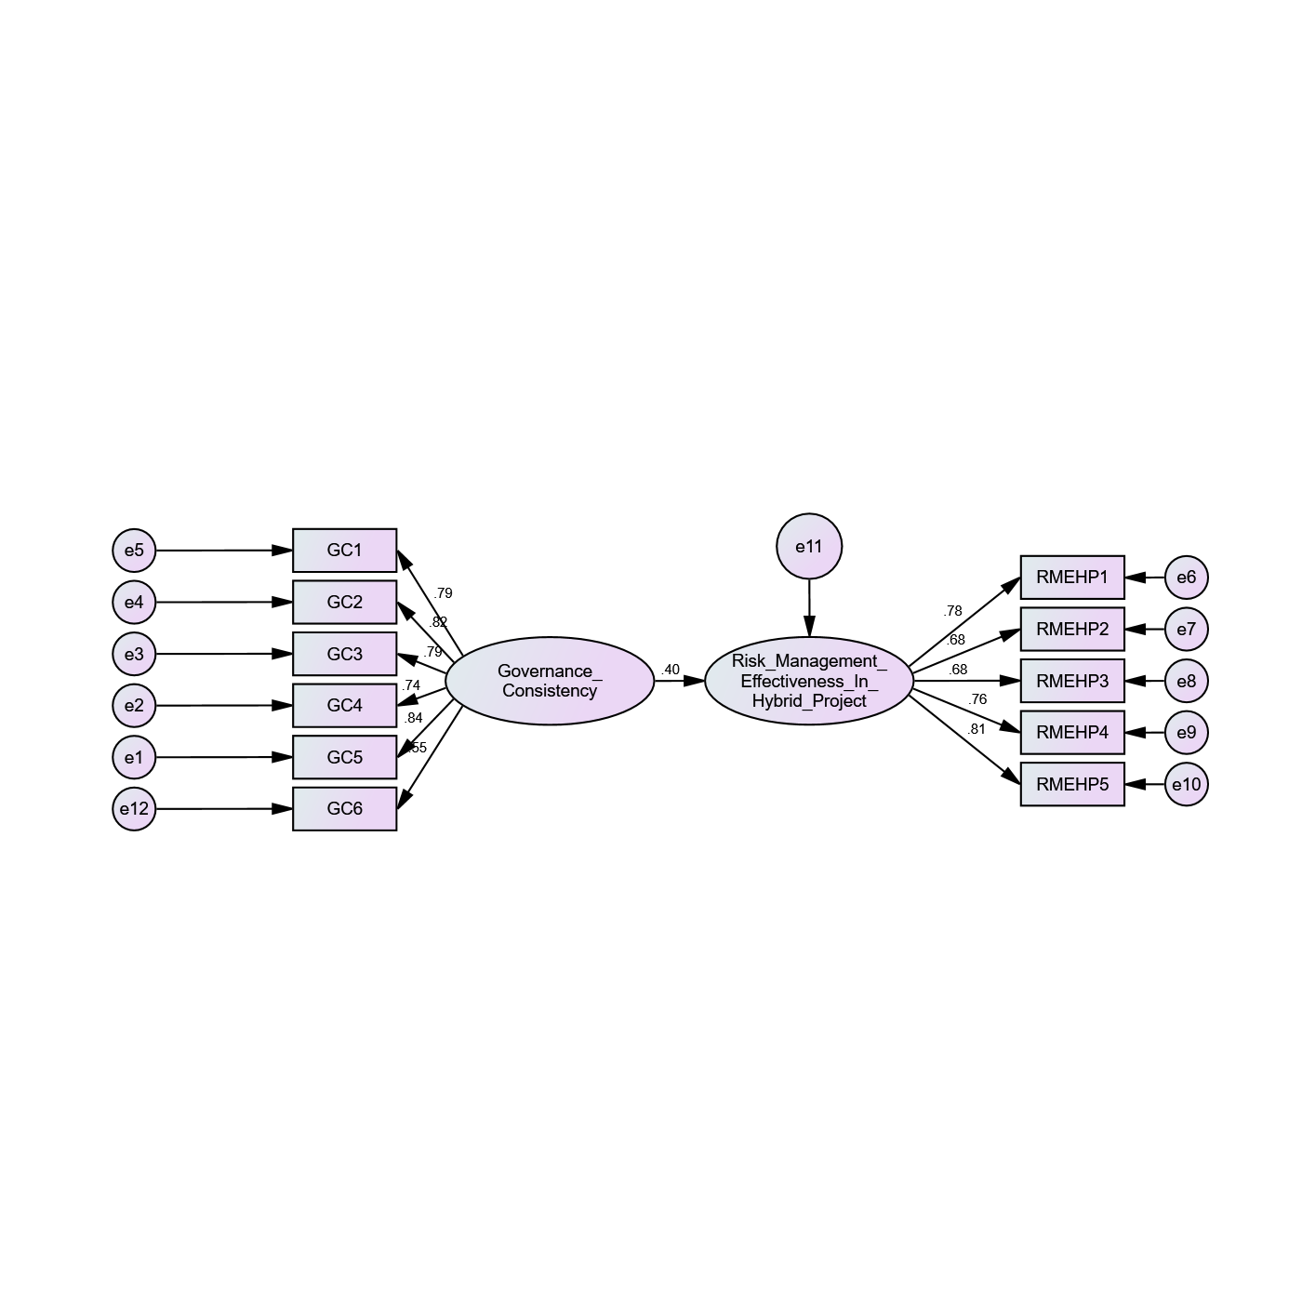
Hypothesis 4 was tested using Structural Equation Modelling (SEM) to examine the direct influence of Governance Consistency on Risk Management Effectiveness in Hybrid Projects. The results presented in Table 7 (Regression Weights: Group number 1 – Default model) reveal that Governance Consistency has a statistically significant and positive effect on Risk Management Effectiveness (Standardized Estimate = 0.397, S.E. = 0.054, C.R. = 6.869, p < 0.001). The standardized coefficient of 0.397 indicates a moderate and practically meaningful relationship, suggesting that consistent application of governance structures, policies, accountability mechanisms, and reporting standards significantly enhances the effectiveness of risk management in hybrid project environments. The critical ratio (C.R. = 6.869) substantially exceeds the recommended threshold of 1.96, confirming strong statistical significance. Accordingly, the null hypothesis (H04) is rejected, and Hypothesis 4 is supported.
Table 16 Regression Weights: (Group number 1 - Default model)
 |  |  | Estimate | S.E. | C.R. | P
Risk Management Effectiveness in Hybrid Project | <--- | Governance consistency | 0.397 | 0.054 | 6.869 | ***
GC1 | <--- | Governance consistency | 0.841
GC2 | <--- | Governance consistency | 0.738 | 0.052 | 16.26 | ***
GC3 | <--- | Governance consistency |  | 0.054 | 18.04 | ***
GC4 | <--- | Governance consistency | 0.819 | 0.053 | 18.841 | ***
GC5 | <--- | Governance consistency | 0.791 | 0.055 | 17.908 | ***
RMEHP1 | <--- | Risk Management Effectiveness in Hybrid Project | 0.778
RMEHP2 | <--- | Risk Management Effectiveness in Hybrid Project | 0.683 | 0.063 | 13.182 | ***
RMEHP3 | <--- | Risk Management Effectiveness in Hybrid Project | 0.678 | 0.06 | 13.092 | ***
RMEHP4 | <--- | Risk Management Effectiveness in Hybrid Project | 0.757 | 0.062 | 14.756 | ***
RMEHP5 | <--- | Risk Management Effectiveness in Hybrid Project | 0.814 | 0.063 | 15.881 | ***
RMEHP5 | <--- | Risk Management Effectiveness in Hybrid Project | 0.546 | 0.061 | 11.071 | ***

The measurement model for Governance Consistency demonstrates satisfactory reliability and construct validity. As shown in Table 7, the factor loadings for GC1–GC6 range from approximately 0.738 to 0.841, all exceeding the acceptable threshold of 0.60. These loadings confirm that the observed indicators adequately represent the underlying construct of Governance Consistency. Similarly, the factor loadings for Risk Management Effectiveness in Hybrid Projects (RMEHP1–RMEHP5) range from 0.678 to 0.814, indicating strong convergence of the measurement items on the dependent construct. The consistency of these loadings across indicators further reinforces the robustness of the measurement model and supports the structural findings.
Table 17 Model Fit Summary
Fit Index | Value
Chi-square (χ²) | 73.809
Degrees of Freedom (df) | 43
CMIN/DF | 1.716
P-value | 0.002
NFI | 0.965
RFI | 0.955
IFI | 0.985
CFI | 0.985
RMSEA | 0.043
The overall model fit indices associated with Hypothesis 4 indicate an acceptable and well-fitting model. As reported in the fit statistics accompanying Table 7, the Chi-square value (χ² = 73.809) with 43 degrees of freedom yields a CMIN/DF ratio of 1.716, which is comfortably below the threshold of 3.00, indicating satisfactory model adequacy. Although the p-value is 0.002, the significance of the Chi-square statistic is commonly observed in larger samples and does not necessarily indicate poor model fit. Additional incremental fit indices further support model adequacy, with NFI = 0.965, RFI = 0.955, IFI = 0.985, and CFI = 0.985, all exceeding the recommended benchmark of 0.90. The RMSEA value of 0.043 is well below the acceptable upper limit of 0.08, indicating a strong approximation fit. Collectively, these indices confirm that the structural model for Governance Consistency demonstrates good overall fit with the observed data.
The findings highlight the strategic importance of consistent governance mechanisms in hybrid project settings. Hybrid environments often combine Agile flexibility with Waterfall structure, which can create ambiguity in authority, accountability, and decision-making processes. Governance Consistency ensures that risk oversight, reporting structures, escalation pathways, and compliance standards are uniformly applied across methodologies. This alignment reduces confusion, strengthens accountability, and enhances strategic risk oversight, ultimately improving risk management outcomes. The moderate strength of the path coefficient suggests that governance consistency functions as a structural backbone that stabilizes risk management practices across diverse project execution approaches.
Based on the statistically significant path coefficient, acceptable model fit indices, and strong measurement properties reported in Table 7, Hypothesis 4 is accepted. Governance Consistency has a significant positive impact on Risk Management Effectiveness in Hybrid Project Environments.

Hypothesis 5
H5: AI-Driven Risk Analytics Capability has a significant positive impact on Risk Management Effectiveness in Hybrid Project Environments.
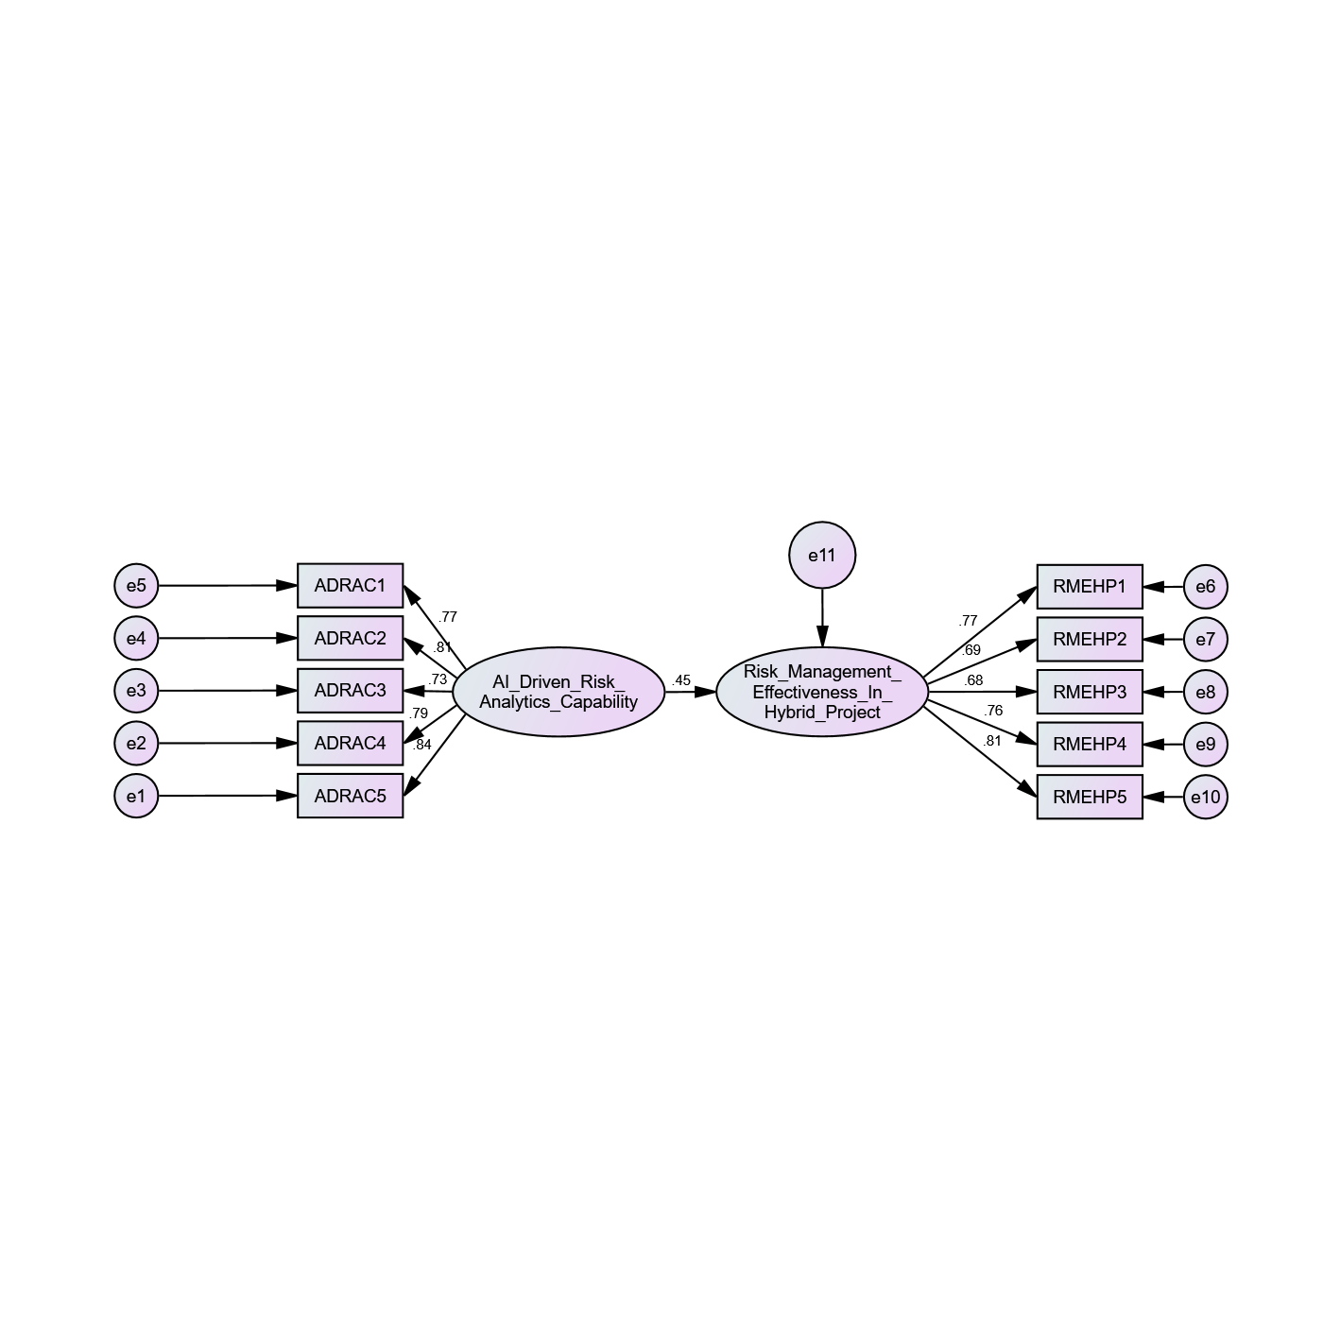
Hypothesis 5 was tested using Structural Equation Modelling (SEM) to evaluate the direct influence of AI-Driven Risk Analytics Capability on Risk Management Effectiveness in Hybrid Projects. The regression results indicate a standardized path coefficient of 0.449 (S.E. = 0.051, C.R. = 7.697, p < 0.001), demonstrating a statistically significant and positive relationship between AI-Driven Risk Analytics Capability and Risk Management Effectiveness. The critical ratio (C.R. = 7.697) substantially exceeds the recommended threshold of 1.96, confirming strong statistical significance. The standardized estimate of 0.449 reflects a moderate-to-strong practical effect, indicating that enhanced AI-driven analytics capability meaningfully improves the effectiveness of risk management practices in hybrid project environments. Therefore, the null hypothesis (H05) is rejected, and Hypothesis 5 is supported.
Table 18 SEM Results for H5: AI-Driven Risk Analytics Capability → Risk Management Effectiveness
 |  |  | Estimate | S.E. | C.R. | P
Risk Management Effectiveness in Hybrid Project | <--- | AI Driven Risk Analytics Capability | 0.449 | 0.051 | 7.697 | ***
ADRAC1 | <--- | AI Driven Risk Analytics Capability | 0.836
ADRAC2 | <--- | AI Driven Risk Analytics Capability | 0.791 | 0.053 | 17.526 | ***
ADRAC3 | <--- | AI Driven Risk Analytics Capability | 0.732 | 0.056 | 15.794 | ***
ADRAC4 | <--- | AI Driven Risk Analytics Capability | 0.809 | 0.054 | 18.068 | ***
ADRAC5 | <--- | AI Driven Risk Analytics Capability | 0.775 | 0.053 | 17.049 | ***
RMEHP1 | <--- | Risk Management Effectiveness in Hybrid Project | 0.774
RMEHP2 | <--- | Risk Management Effectiveness in Hybrid Project | 0.686 | 0.063 | 13.217 | ***
RMEHP3 | <--- | Risk Management Effectiveness in Hybrid Project | 0.683 | 0.061 | 13.145 | ***
RMEHP4 | <--- | Risk Management Effectiveness in Hybrid Project | 0.758 | 0.062 | 14.718 | ***
RMEHP5 | <--- | Risk Management Effectiveness in Hybrid Project | 0.811 | 0.063 | 15.758 | ***

The measurement properties of the AI-Driven Risk Analytics Capability construct demonstrate strong reliability and convergent validity. The factor loadings for ADRAC1–ADRAC5 range from 0.732 to 0.836, all exceeding the acceptable benchmark of 0.60, indicating that the indicators reliably represent the latent construct. These results confirm that the measurement items effectively capture the organization’s capability to utilize artificial intelligence, machine learning algorithms, predictive analytics tools, and automated risk detection mechanisms in project risk management. Likewise, the factor loadings for Risk Management Effectiveness in Hybrid Projects (RMEHP1–RMEHP5) range from 0.683 to 0.811, confirming the robustness and internal consistency of the dependent construct. The strength and consistency of these loadings reinforce the validity of the structural relationship observed.
Table 19 Model Fit Indices for H5 Structural Model
Fit Index | Value
Chi-square (χ²) | 67.817
Degrees of Freedom (df) | 34
CMIN/DF | 1.995
P-value | 0.000
NFI | 0.965
RFI | 0.954
IFI | 0.982
CFI | 0.982
RMSEA | 0.051

The model fit statistics further support the adequacy of the structural model. As indicated in the fit indices, the Chi-square value (χ² = 67.817) with 34 degrees of freedom yields a CMIN/DF ratio of 1.995, which falls within the acceptable threshold of less than 3.00, indicating satisfactory model fit. Although the Chi-square p-value is significant (p = 0.000), this is common in studies with larger sample sizes and does not necessarily imply poor fit. Additional incremental fit indices confirm the model’s adequacy, with NFI = 0.965, RFI = 0.954, IFI = 0.982, and CFI = 0.982, all exceeding the recommended benchmark of 0.90. The RMSEA value of 0.051 is below the upper threshold of 0.08, indicating good approximation fit. Collectively, these indices demonstrate that the structural model provides a good representation of the observed data.
The findings underscore the strategic importance of AI-driven risk analytics capability in hybrid project environments. Unlike traditional risk management mechanisms that rely heavily on manual assessment and historical judgment, AI-enabled analytics enhances predictive accuracy, anomaly detection, real-time monitoring, and automated prioritization of risks. In hybrid environments where methodological complexity and information fragmentation can impede risk transparency AI capability functions as an integrative and intelligence-enhancing mechanism. The comparatively strong standardized coefficient suggests that AI-driven analytics capability is one of the most influential determinants of risk management effectiveness among the variables tested in this study.
Based on the statistically significant path coefficient, acceptable goodness-of-fit indices, and strong measurement reliability, Hypothesis 5 is accepted. AI-Driven Risk Analytics Capability has a significant positive impact on Risk Management Effectiveness in Hybrid Project Environments.

CHAPTER 5

DISCUSSION
The purpose of this study was to examine how governance mechanisms and artificial intelligence–enabled analytics influence project risk management effectiveness in hybrid project environments. Using structural equation modeling, the research evaluated the relative contributions of governance consistency, risk process alignment, risk visibility, timely risk escalation, and AI analytics capability. The findings reveal that risk management effectiveness in hybrid projects is driven primarily by structural coherence and organizational capability rather than by information availability or escalation speed alone. This highlights an important shift in how risk is governed in complex project settings that combine Agile and traditional methodologies.
One of the most significant findings is the strong positive effect of governance consistency on risk management effectiveness. Hybrid projects frequently operate under dual governance logics, where Agile teams emphasize autonomy and flexibility while traditional structures rely on formal controls and hierarchical oversight. When these governance systems are inconsistently applied, ambiguity emerges around accountability, decision rights, and escalation pathways, increasing the likelihood of unmanaged risks. The results of this study indicate that consistent governance across hybrid structures reduces such ambiguity and enhances coordination, supporting existing governance and agency theory perspectives that emphasize the importance of clarity in roles and authority. This suggests that effective risk management in hybrid projects requires deliberate integration of governance mechanisms rather than parallel or fragmented control systems.
Risk process alignment also demonstrated a significant positive relationship with risk management effectiveness, reinforcing the importance of structural integration across the project lifecycle. Hybrid environments often exhibit misaligned risk practices, with Agile teams relying on informal, iterative approaches and traditional teams adhering to formalized risk registers and stage-gate reviews. The findings suggest that aligning these processes into a coherent risk management framework enables organizations to identify, assess, and respond to risks more effectively. From a dynamic capabilities perspective, this alignment enhances an organization’s ability to sense and adapt to uncertainty by ensuring that risk information flows consistently across teams and decision levels. This reinforces prior research that identifies process integration as a critical success factor in complex project environments.
In contrast, risk visibility did not demonstrate a statistically significant direct effect on risk management effectiveness. While prior studies often emphasize transparency and information sharing as key enablers of effective risk management, the results of this study suggest that visibility alone is insufficient in hybrid project contexts. One possible explanation is that increased visibility does not necessarily lead to improved decision-making if governance structures and interpretive mechanisms are weak. In hybrid projects, risk information may be widely available but not effectively prioritized or acted upon due to competing decision logics or unclear accountability. Additionally, Agile environments generate high volumes of real-time data, which can contribute to information overload rather than enhanced situational awareness. These findings indicate that risk visibility functions more as an enabling condition that supports other governance mechanisms, rather than as an independent driver of effectiveness.
Similarly, timely risk escalation was not found to have a significant direct impact on risk management effectiveness. This challenges traditional assumptions that rapid escalation is inherently beneficial in managing project risks. In hybrid project environments, Agile principles encourage decentralized decision-making and local problem resolution, reducing the need for frequent formal escalation. Rapid escalation of risks that can be managed at the team level may create unnecessary disruption, increase administrative burden, and undermine team autonomy. The results suggest that escalation effectiveness in hybrid projects depends more on appropriateness and quality than on speed. This aligns with emerging literature that argues for context-sensitive escalation policies, particularly in environments characterized by high uncertainty and adaptive workflows.
AI analytics capability emerged as one of the strongest predictors of risk management effectiveness, underscoring its growing strategic importance in contemporary project management. Rather than functioning solely as a technical tool, AI analytics appears to operate as an organizational capability that enhances predictive foresight and decision quality. By continuously analyzing large volumes of project data, AI systems enable early detection of emerging risks and support proactive decision-making. From a resource-based view, AI analytics capability represents a valuable and difficult-to-imitate resource that can strengthen an organization’s risk governance capacity. Importantly, the findings suggest that AI does not replace traditional governance mechanisms but amplifies their effectiveness by reducing cognitive limitations and improving situational awareness within structured risk processes.
Taken together, the findings indicate that effective risk management in hybrid projects is shaped by the interaction between governance structures, aligned processes, and advanced analytical capabilities. Structural coherence provides the foundation for effective risk governance, while AI analytics enhances an organization’s ability to adapt to uncertainty. The non-significant effects of risk visibility and escalation highlight that risk management effectiveness is not determined by information availability or response speed alone, but by the organization’s capacity to interpret information and make coordinated decisions. This integrated perspective advances existing project risk management literature by empirically demonstrating how hybrid governance and AI-enabled capabilities jointly influence outcomes.
From a theoretical standpoint, this study contributes to the growing body of hybrid project management literature by validating a multidimensional model of risk governance that incorporates AI analytics capability. It extends governance and dynamic capability theories into the hybrid project domain, emphasizing the evolving role of AI in supporting organizational control and adaptability. Practically, the findings suggest that organizations managing hybrid projects should prioritize governance integration and process alignment before investing heavily in visibility tools or escalation mechanisms. AI analytics initiatives are most effective when embedded within coherent governance frameworks that support informed and timely decision-making.
Overall, this discussion highlights that managing risk in hybrid project environments requires more than adopting Agile practices or deploying advanced technologies in isolation. Instead, organizations must focus on creating integrated governance structures, aligning risk processes, and developing analytical capabilities that collectively support effective risk management in complex and dynamic project settings.

CHAPTER 6

CONCLUSION
This study set out to examine how governance mechanisms and artificial intelligence–driven analytics influence risk management effectiveness within hybrid project environments. As organizations increasingly adopt hybrid methodologies that combine Agile and traditional approaches, managing project risk has become more complex due to fragmented governance structures, divergent decision-making logics, and increasing environmental uncertainty. By integrating governance consistency, risk process alignment, risk visibility, timely risk escalation, and AI-driven risk analytics capability into a single structural model, this research provides empirical insights into the factors that most strongly shape risk management outcomes in hybrid projects.
Using a quantitative research design and structural equation modeling (SEM) based on data collected from 384 project professionals, the study demonstrates that risk management effectiveness in hybrid projects is primarily driven by structural coherence and organizational capability rather than by information availability or procedural speed alone. Governance consistency, risk process alignment, and AI-driven risk analytics capability emerged as statistically significant predictors of effective risk management, while risk visibility and timely risk escalation did not exhibit significant direct effects. These findings highlight the importance of integrating governance structures and aligning risk processes across hybrid project settings, while also recognizing the transformative role of AI analytics as an enabler of informed and adaptive decision-making.
One of the most important contributions of this study lies in its empirical validation of governance consistency as a foundational determinant of risk management effectiveness in hybrid projects. Hybrid environments often operate under competing governance logics, where Agile teams prioritize flexibility and decentralized authority, while traditional project structures emphasize formal controls and hierarchical oversight. The findings indicate that when governance mechanisms are applied consistently across these domains, organizations experience improved accountability, clearer decision rights, and more coordinated risk responses. This reinforces the view that hybrid project success does not arise from choosing between Agile and traditional governance models, but from deliberately integrating them into a coherent governance framework.
Risk process alignment also plays a critical role in enhancing risk management effectiveness. The alignment of risk identification, assessment, response planning, and monitoring activities across hybrid project components ensures that risk-related information flows consistently and that responses are coordinated across teams and organizational levels. The findings suggest that misaligned or fragmented risk processes undermine an organization’s ability to manage uncertainty effectively, even when advanced tools or technologies are available. This underscores the importance of viewing risk management as an end-to-end organizational process rather than a collection of isolated practices.
A key insight from this research is the strategic significance of AI-driven risk analytics capability. The results demonstrate that AI analytics is not merely a supportive technological tool but functions as an organizational capability that enhances predictive foresight, decision quality, and adaptive responsiveness. By continuously analyzing large volumes of project data, AI systems enable early identification of emerging risks and support proactive intervention. From a strategic perspective, AI-driven analytics can be understood as a capability that complements and amplifies governance structures, reducing cognitive limitations and enhancing situational awareness in complex project environments. This finding is particularly relevant as organizations increasingly invest in digital transformation initiatives without fully integrating them into governance and risk management frameworks.
Conversely, the non-significant findings related to risk visibility and timely risk escalation challenge some conventional assumptions in project risk management literature. While transparency and rapid escalation are often viewed as inherently beneficial, the results of this study suggest that these factors do not directly translate into effective risk management outcomes in hybrid environments. Risk visibility, while necessary, appears insufficient on its own if organizations lack the governance clarity and interpretive capacity required to act on available information. Similarly, timely risk escalation may be less critical in hybrid projects where Agile teams are empowered to manage risks locally and where premature escalation can disrupt workflows or undermine team autonomy. These findings suggest that risk management effectiveness depends more on the quality of governance and decision-making than on the speed or volume of information flows.
Taken together, the results of this study support an integrated view of risk management in hybrid projects, where governance consistency, aligned processes, and analytical capabilities jointly shape outcomes. Rather than treating risk management as a purely technical or procedural function, the findings emphasize its organizational and strategic dimensions. Effective risk management in hybrid environments requires deliberate governance design, cross-method integration, and the development of capabilities that support adaptive decision-making under uncertainty.
From a theoretical perspective, this study contributes to the growing body of literature on hybrid project management by empirically validating a multidimensional model of risk governance that incorporates AI-driven analytics capability. While prior research has often examined Agile and traditional risk management practices in isolation, this study advances understanding by demonstrating how governance and technology interact within hybrid contexts. The findings extend governance theory by highlighting the importance of consistency across multiple project methodologies, and they contribute to dynamic capability theory by positioning AI analytics as a capability that enhances organizational adaptability in uncertain environments.
The study also contributes to the emerging literature on AI in project management by moving beyond descriptive accounts of tool adoption and focusing on AI as a capability embedded within governance and process structures. By empirically demonstrating the impact of AI analytics capability on risk management effectiveness, this research provides a foundation for future studies exploring the strategic role of AI in complex organizational systems. Importantly, the findings caution against viewing AI as a standalone solution, emphasizing instead the need for integration with governance frameworks and aligned processes.
From a practical standpoint, the findings offer several important implications for project managers, organizations, and policymakers. Organizations managing hybrid projects should prioritize the development of consistent governance frameworks that bridge Agile and traditional approaches. Rather than allowing governance practices to evolve independently within different project components, organizations should establish clear principles that define decision rights, accountability, and escalation pathways across hybrid structures. This requires not only formal policies but also cultural alignment and leadership commitment.
In addition, organizations should invest in aligning risk management processes across hybrid project environments. This includes harmonizing risk identification methods, assessment criteria, and monitoring mechanisms to ensure that risk information is comparable and actionable across teams. Such alignment enhances coordination and reduces the likelihood that critical risks will be overlooked or mismanaged due to process fragmentation.
The findings also suggest that investments in AI-driven risk analytics should be accompanied by parallel investments in governance and capability development. Simply deploying AI tools without integrating them into decision-making processes and governance structures is unlikely to yield meaningful improvements in risk management effectiveness. Organizations should focus on developing the skills, routines, and organizational structures necessary to interpret and act on AI-generated insights. This includes training project managers and decision-makers to understand predictive analytics and to integrate AI outputs into strategic and operational decisions.
Despite its contributions, this study is subject to several limitations that should be acknowledged. First, the research adopts a cross-sectional design, which limits the ability to draw causal inferences or examine how risk management practices evolve over time. Longitudinal studies could provide deeper insights into how governance mechanisms and AI capabilities interact across different project phases. Second, the study focuses on a sample drawn from India, which may limit the generalizability of the findings to other geographic or cultural contexts. While India provides a relevant context due to its widespread adoption of hybrid project methodologies, future research could replicate the model in different regions to assess its broader applicability.
Third, the study relies on self-reported perceptions of project professionals, which may be subject to response bias. Although the sample size is adequate and the measurement model demonstrates acceptable reliability and validity, future studies could complement survey data with objective performance metrics or qualitative case studies. Additionally, while this study focuses on direct relationships between constructs, future research could explore mediating or moderating effects, such as organizational culture, project complexity, or regulatory environments.
Future research could also extend this work by examining how AI-driven risk analytics interacts with specific Agile practices, such as sprint planning or retrospectives, and with traditional governance mechanisms, such as stage-gate reviews. Exploring the ethical and organizational implications of AI adoption in project risk management, including issues related to transparency, trust, and accountability, would further enrich understanding in this area.
In conclusion, this study demonstrates that effective risk management in hybrid project environments is not achieved through isolated practices or technologies, but through the integration of consistent governance, aligned processes, and advanced analytical capabilities. As hybrid methodologies continue to shape project management practice, organizations must move beyond simplistic dichotomies between Agile and traditional approaches and instead focus on building coherent systems that support informed and adaptive decision-making. By doing so, they can enhance their ability to manage uncertainty, protect stakeholder value, and achieve sustained project success in increasingly complex and dynamic environments.

References
Abazid, M., & Harb, H. (2018). An overview of risk management in the construction projects. 9(June), 73–79.
Abid, S. K., Sulaiman, N., Chan, S. W., Nazir, U., Abid, M., Han, H., Ariza-Montes, A., & Vega-Munoz, A. (2021). Toward an integrated disaster management approach: how artificial intelligence can boost disaster management. Sustainability, 13(22), 12560.
Adebayo, O. (2024). Project Risk Management Strategies: Best Practices for Identifying, Assessing, and Mitigating Risks in Project Management. Volume 7 Issue 10 April-2024, 371–381.
Afzal, F., Yunfei, S., Nazir, M., & Bhatti, S. M. (2021). A review of artificial intelligence based risk assessment methods for capturing complexity-risk interdependencies: Cost overrun in construction projects. International Journal of Managing Projects in Business, 14(2), 300–328.
Ahmed, Q. W., Garg, S., Rai, A., Ramachandran, M., Jhanjhi, N. Z., Masud, M., & Baz, M. (2022). Ai-based resource allocation techniques in wireless sensor internet of things networks in energy efficiency with data optimization. Electronics, 11(13), 2071.
Awang, Z. (2014). Validating the Measurement Model : Cfa. Structural Equation Modelling Using Amos Grafic, 54–73.
Aziz, S., & Dowling, M. (2019). Machine learning and AI for risk management, disrupting finance: FinTech and strategy in the 21st century. Springer International Publishing: Berlin/Heidelberg, Germany.
Bansal, M.; Goyal, A.; Choudhary, A. A. (2022). Comparative analysis of K-nearest neighbor, genetic, support vector machine, decision tree, and long short term memory algorithms in machine learning.
Baryannis, G., Validi, S., Dani, S., & Antoniou, G. (2019). Supply chain risk management and artificial intelligence: state of the art and future research directions. International Journal of Production Research, 57(7), 2179–2202.
Belhadi, A., Kamble, S., Fosso Wamba, S., & Queiroz, M. M. (2022). Building supply-chain resilience: an artificial intelligence-based technique and decision-making framework. International Journal of Production Research, 60(14), 4487–4507.
Bjorvatn, T., & Wald, A. (2023). Project management in turbulent times: Hybrid approaches for dynamic environments. International Journal of Project Management, 41(1), 102–112.
Cheung, G. W., Cooper-Thomas, H. D., Lau, R. S., & Wang, L. C. (2024). Reporting reliability, convergent and discriminant validity with structural equation modeling: A review and best-practice recommendations. In Asia Pacific Journal of Management (Vol. 41, Issue 2). Springer US. https://doi.org/10.1007/s10490-023-09871-y
Datta, P., & Roy, R. (2010). Cost Modelling Techniques for Availability Type Service Support Contracts: A Literature Review and Empirical Study. Cirp Journal of Manufacturing Science and Technology, 3. https://doi.org/10.1016/j.cirpj.2010.07.003
de Araújo Lima, P. F., Crema, M., & Verbano, C. (2020). Risk management in SMEs: A systematic literature review and future directions. European Management Journal, 38(1), 78–94.
Denicol, J., Davies, A., & Pryke, S. (2022). The organizational architecture of megaprojects: The hybrid project management approach. Project Management Journal, 53(2), 132–145.
Dutta, D., & Bose, I. (2015). Managing risks in AI-enabled business processes. Information Systems Journal.
Ebule, A. (2025). DEVELOPING A ROBUST PROJECT RISK MANAGEMENT PLAN : PRINCIPLES , STRATEGIES , AND IMPLEMENTATION. 10(1).
Faruk, M. I. (2025). AI-Driven Project Risk Management: Leveraging Artificial Intelligence. Journal of Computer Science and Technology Studies, 123–137. https://doi.org/10.32996/jcsts
Galaz, V., Centeno, M. A., Callahan, P. W., Causevic, A., Patterson, T., Brass, I., Baum, S., Farber, D., Fischer, J., & Garcia, D. (2021). Artificial intelligence, systemic risks, and sustainability. Technology in Society, 67, 101741.
He, R., Zhang, L., & Chew, A. (2022). Modeling and predicting rainfall time series using seasonal-trend decomposition and machine learning. Knowledge-Based Systems, 251, 109125. https://doi.org/10.1016/j.knosys.2022.109125
Hoda, R., & Murugesan, L. K. (2023). Agile project management in non-software domains: Challenges and adaptations. IEEE Transactions on Engineering Management, 70(2), 591–604.
Hopkin, P. (2018). Fundamentals of Risk Management: Understanding, Evaluating and Implementing Effective Risk Management; Kogan Page Publishers: London, UK,.
Hosseini, M. R., Martek, I., & Zavadskas, E. K. (2023). Hybridization in project management: A systematic review and future research agenda. Journal of Civil Engineering and Management, 29(1), 1–14.
Ibrahim, A., & Bezverkhyi, K. (2024). Risk Management in Hybrid Project Environments: Combining Sequential Planning with Iterative Delivery.
Isensee, C., Griese, K.-M., & Teuteberg, F. (2021). Sustainable artificial intelligence: A corporate culture perspective. Sustainability Management Forum| NachhaltigkeitsManagementForum, 29(3), 217–230.
Jacob, D. (2025). International Journal of Research Publication and Reviews Agile Hybrid Methodologies for Complex Project Execution : Balancing Flexibility , Control , and Stakeholder Value Maximization . 6(3), 6190–6202.
Javaid, M., Haleem, A., Pratap Singh, R., Khan, S., & Suman, R. (2022). Sustainability 4.0 and its applications in the field of manufacturing. Internet of Things and Cyber-Physical Systems, 2, 82–90. https://doi.org/https://doi.org/10.1016/j.iotcps.2022.06.001
Kaplan, S., & Garrick, B. J. (1981). On the quantitative definition of risk. Risk Analysis, 1(1), 11–27.
Kapri, S. S. (2023). The role of corporate governance in mitigating financial risk: An Indian experiences. Journal of Cardiovascular Research, 12(6), 2114–2121.
Kerzner, H. (2023). Project based problem solving and decision making: a guide for project managers. John Wiley & Sons.
Khan, M. A., & Al-Shammari, M. (2023). Exploring Agile applicability in infrastructure projects: A critical analysis. International Journal of Managing Projects in Business, 16(5), 1083–1103.
Leech, B. (2025). The Evolution of Agile and Hybrid Project Management Methodologies : A Systematic Literature Review. 1, 4–13.
Lundqvist, S. A. (2015). Why firms implement risk governance–Stepping beyond traditional risk management to enterprise risk management. Journal of Accounting and Public Policy, 34(5), 441–466.
Matel, E., Vahdatikhaki, F., Hosseinyalamdary, S., Evers, T., & Voordijk, H. (2022). An artificial neural network approach for cost estimation of engineering services. International Journal of Construction Management, 22(7), 1274–1287.
Mirzaei, M., Mabin, V. J., & Zwikael, O. (2025). Customising Hybrid project management methodologies. Production Planning & Control, 36(9), 1188–1205. https://doi.org/10.1080/09537287.2024.2349231
Nguyen, Q. K. (2022). The impact of risk governance structure on bank risk management effectiveness: evidence from ASEAN countries. Heliyon, 8(10).
Nwosu, N., & Peter, C. (2025). International Journal of Research Publication and Reviews Integrating Automation into Project Management for Enhanced Risk Identification , Assessment , and Mitigation : A Strategic Framework for Improving Project Success . 6(10), 291–306.
Okafor, I. (2021). PROJECT RISK MANAGEMENT.
Pan, Y., & Zhang, L. (2021). Roles of artificial intelligence in construction engineering and management: A critical review and future trends. Automation in Construction, 122, 103517. https://doi.org/10.1016/j.autcon.2020.103517
Peri, S. S. S. R. G. (2025). AI-Based Risk Assessment Tools in Project Planning and Execution. https://doi.org/https://doi.org/10.52783/eel.v15i2.3018
Praveen, R. (2025). Agile vs. Hybrid Project Management Methodologies in Large-Scale Infrastructure Projects. Journal of Marketing & Social Research.
Ruggiano, N., & Perry, T. E. (2019). Conducting secondary analysis of qualitative data: Should we, can we, and how? Qualitative Social Work, 18(1), 81–97.
Salehi, H., & Burgueño, R. (2018). Emerging artificial intelligence methods in structural engineering. Engineering Structures, 171, 170–189. https://doi.org/10.1016/j.engstruct.2018.05.084
Schaffer, A., Dobbins, T., & Pearson, S.-A. (2021). Interrupted time series analysis using autoregressive integrated moving average (ARIMA) models: a guide for evaluating large-scale health interventions. BMC Medical Research Methodology, 21. https://doi.org/10.1186/s12874-021-01235-8
Schön, E.-M., Radtke, D., & Jordan, C. (2020). Improving Risk Management in a Scaled Agile Environment BT - Agile Processes in Software Engineering and Extreme Programming (V. Stray, R. Hoda, M. Paasivaara, & P. Kruchten (eds.); pp. 132–141). Springer International Publishing.
Schuett, J. (2023). Risk Management in the Artificial Intelligence Act. European Journal of Risk Regulation, 15, 1–19. https://doi.org/10.1017/err.2023.1
Sherstinsky, A. (2020). Fundamentals of Recurrent Neural Network (RNN) and Long Short-Term Memory (LSTM) network. Physica D: Nonlinear Phenomena, 404, 132306. https://doi.org/10.1016/j.physd.2019.132306
Shrestha, N. (2021). Factor Analysis as a Tool for Survey Analysis. American Journal of Applied Mathematics and Statistics, 9(1), 4–11. https://doi.org/10.12691/ajams-9-1-2
Székely, B., Késmárki-Gally, S. E., & Lakner, Z. (2025). Hybrid project management: Scoping review. Project Leadership and Society, 6, 100182. https://doi.org/https://doi.org/10.1016/j.plas.2025.100182
Tanim, S. H., & Ahmad, S. (2025). AI driven strategic decision-making in IT project management : Enhancing risk assessment , cost control , and efficiency.
Team, I. E. (2024). An Introductory Guide to Confirmatory Factor Analysis.
Tian, Kun, Z. Z. (2025). Artificial intelligence in risk management within the realm of construction projects: A bibliometric analysis and systematic literature review. Journal of Innovation & Knowledge. https://doi.org/DOI: 10.1016/j.jik.2025.100711
Wenzel, M., Krause, B., & Wagner, S. M. (2022). Predictive risk management using artificial intelligence:
Yaseen, A. (2021). REDUCING INDUSTRIAL RISK WITH AI AND AUTOMATION.
Yigitcanlar, T. (2021). Greening the artificial intelligence for a sustainable planet: An editorial commentary. In Sustainability (Vol. 13, Issue 24, p. 13508). MDPI.
Zigiene, G., Rybakovas, E., & Alzbutas, R. (2019). Artificial Intelligence Based Commercial Risk Management Framework for SMEs. Sustainability, 11, 4501. https://doi.org/10.3390/su11164501
Aven, T. (2016). Risk assessment and risk management: Review of recent advances on their foundation. European Journal of Operational Research, 253(1), 1–13.
Aven, T., & Renn, O. (2010). Risk management and governance: Concepts, guidelines and applications. Springer.
Biesenthal, C., Sankaran, S., & Vaagaasar, A. L. (2022). Artificial intelligence in project management: Theories, concepts, and future research directions. International Journal of Project Management, 40(4), 323–336.
Bughin, J., Seong, J., Manyika, J., Chui, M., & Joshi, R. (2018). Notes from the AI frontier: Modeling the impact of AI on the world economy. McKinsey Global Institute.
Dwivedi, Y. K., Hughes, L., Ismagilova, E., et al. (2023). Artificial intelligence (AI): Multidisciplinary perspectives on emerging challenges, opportunities, and agenda for research, practice and policy. International Journal of Information Management, 57, 102420.
Elkington, J. (1997). Cannibals with forks: The triple bottom line of 21st century business. Capstone Publishing.
Flyvbjerg, B. (2017). Survival of the unfittest: Why the worst infrastructure gets built—and what we can do about it. Oxford Review of Economic Policy, 25(3), 344–367.
Fountaine, T., McCarthy, B., & Saleh, T. (2019). Building the AI-powered organization. Harvard Business Review, 97(4), 62–73.
Hanaysha, J. R., Al-Shaikh, M. E., & Alzoubi, H. M. (2021). The role of artificial intelligence in improving project performance: Evidence from IT projects. Management Science Letters, 11(5), 1561–1570.
Jordan, M. I., & Mitchell, T. M. (2015). Machine learning: Trends, perspectives, and prospects. Science, 349(6245), 255–260.
Kahneman, D. (2011). Thinking, fast and slow. Farrar, Straus and Giroux.
Kerzner, H. (2019). Project management: A systems approach to planning, scheduling, and controlling (12th ed.). Wiley.
March, J. G. (1991). Exploration and exploitation in organizational learning. Organization Science, 2(1), 71–87.
Marnewick, C., Marnewick, A. L., & Pretorius, J. H. C. (2020). Artificial intelligence in project management: A review. South African Journal of Industrial Engineering, 31(4), 43–55.
Provost, F., & Fawcett, T. (2013). Data science for business. O’Reilly Media.
Raisch, S., & Krakowski, S. (2021). Artificial intelligence and management: The automation–augmentation paradox. Academy of Management Review, 46(1), 192–210.
Sauer, C., Gemino, A., & Reich, B. H. (2007). The impact of size and volatility on IT project performance. Communications of the ACM, 50(11), 79–84.
Siau, K., & Wang, W. (2018). Building trust in artificial intelligence, machine learning, and robotics. Cutting-Edge Technologies, 1(1), 47–53.
Simon, H. A. (1997). Administrative behavior (4th ed.). Free Press.
Standish Group. (2020). CHAOS Report 2020. Standish Group International.
United Nations. (2015). Transforming our world: The 2030 agenda for sustainable development. United Nations General Assembly.
Ward, S., & Chapman, C. (2003). Transforming project risk management into project uncertainty management. International Journal of Project Management, 21(2), 97–105.
Wamba, S. F., Bawack, R. E., Guthrie, C., Queiroz, M. M., & Keogh, J. G. (2021). Big data analytics and artificial intelligence in project management: A systematic review. International Journal of Project Management, 39(6), 633–651.
Williams, T., Klakegg, O. J., Magnussen, O. M., & Glasspool, H. (2010). An investigation of governance frameworks for public project development and estimation. International Journal of Project Management, 28(8), 782–795.
Zhang, L., Chen, X., & Liu, Y. (2021). Predictive analytics for project risk management using machine learning techniques. IEEE Transactions on Engineering Management, 68(4), 1121–1134.

